SUBCOURSE EDITION
AV 0550 B

U. S. ARMY AVIATION CENTER

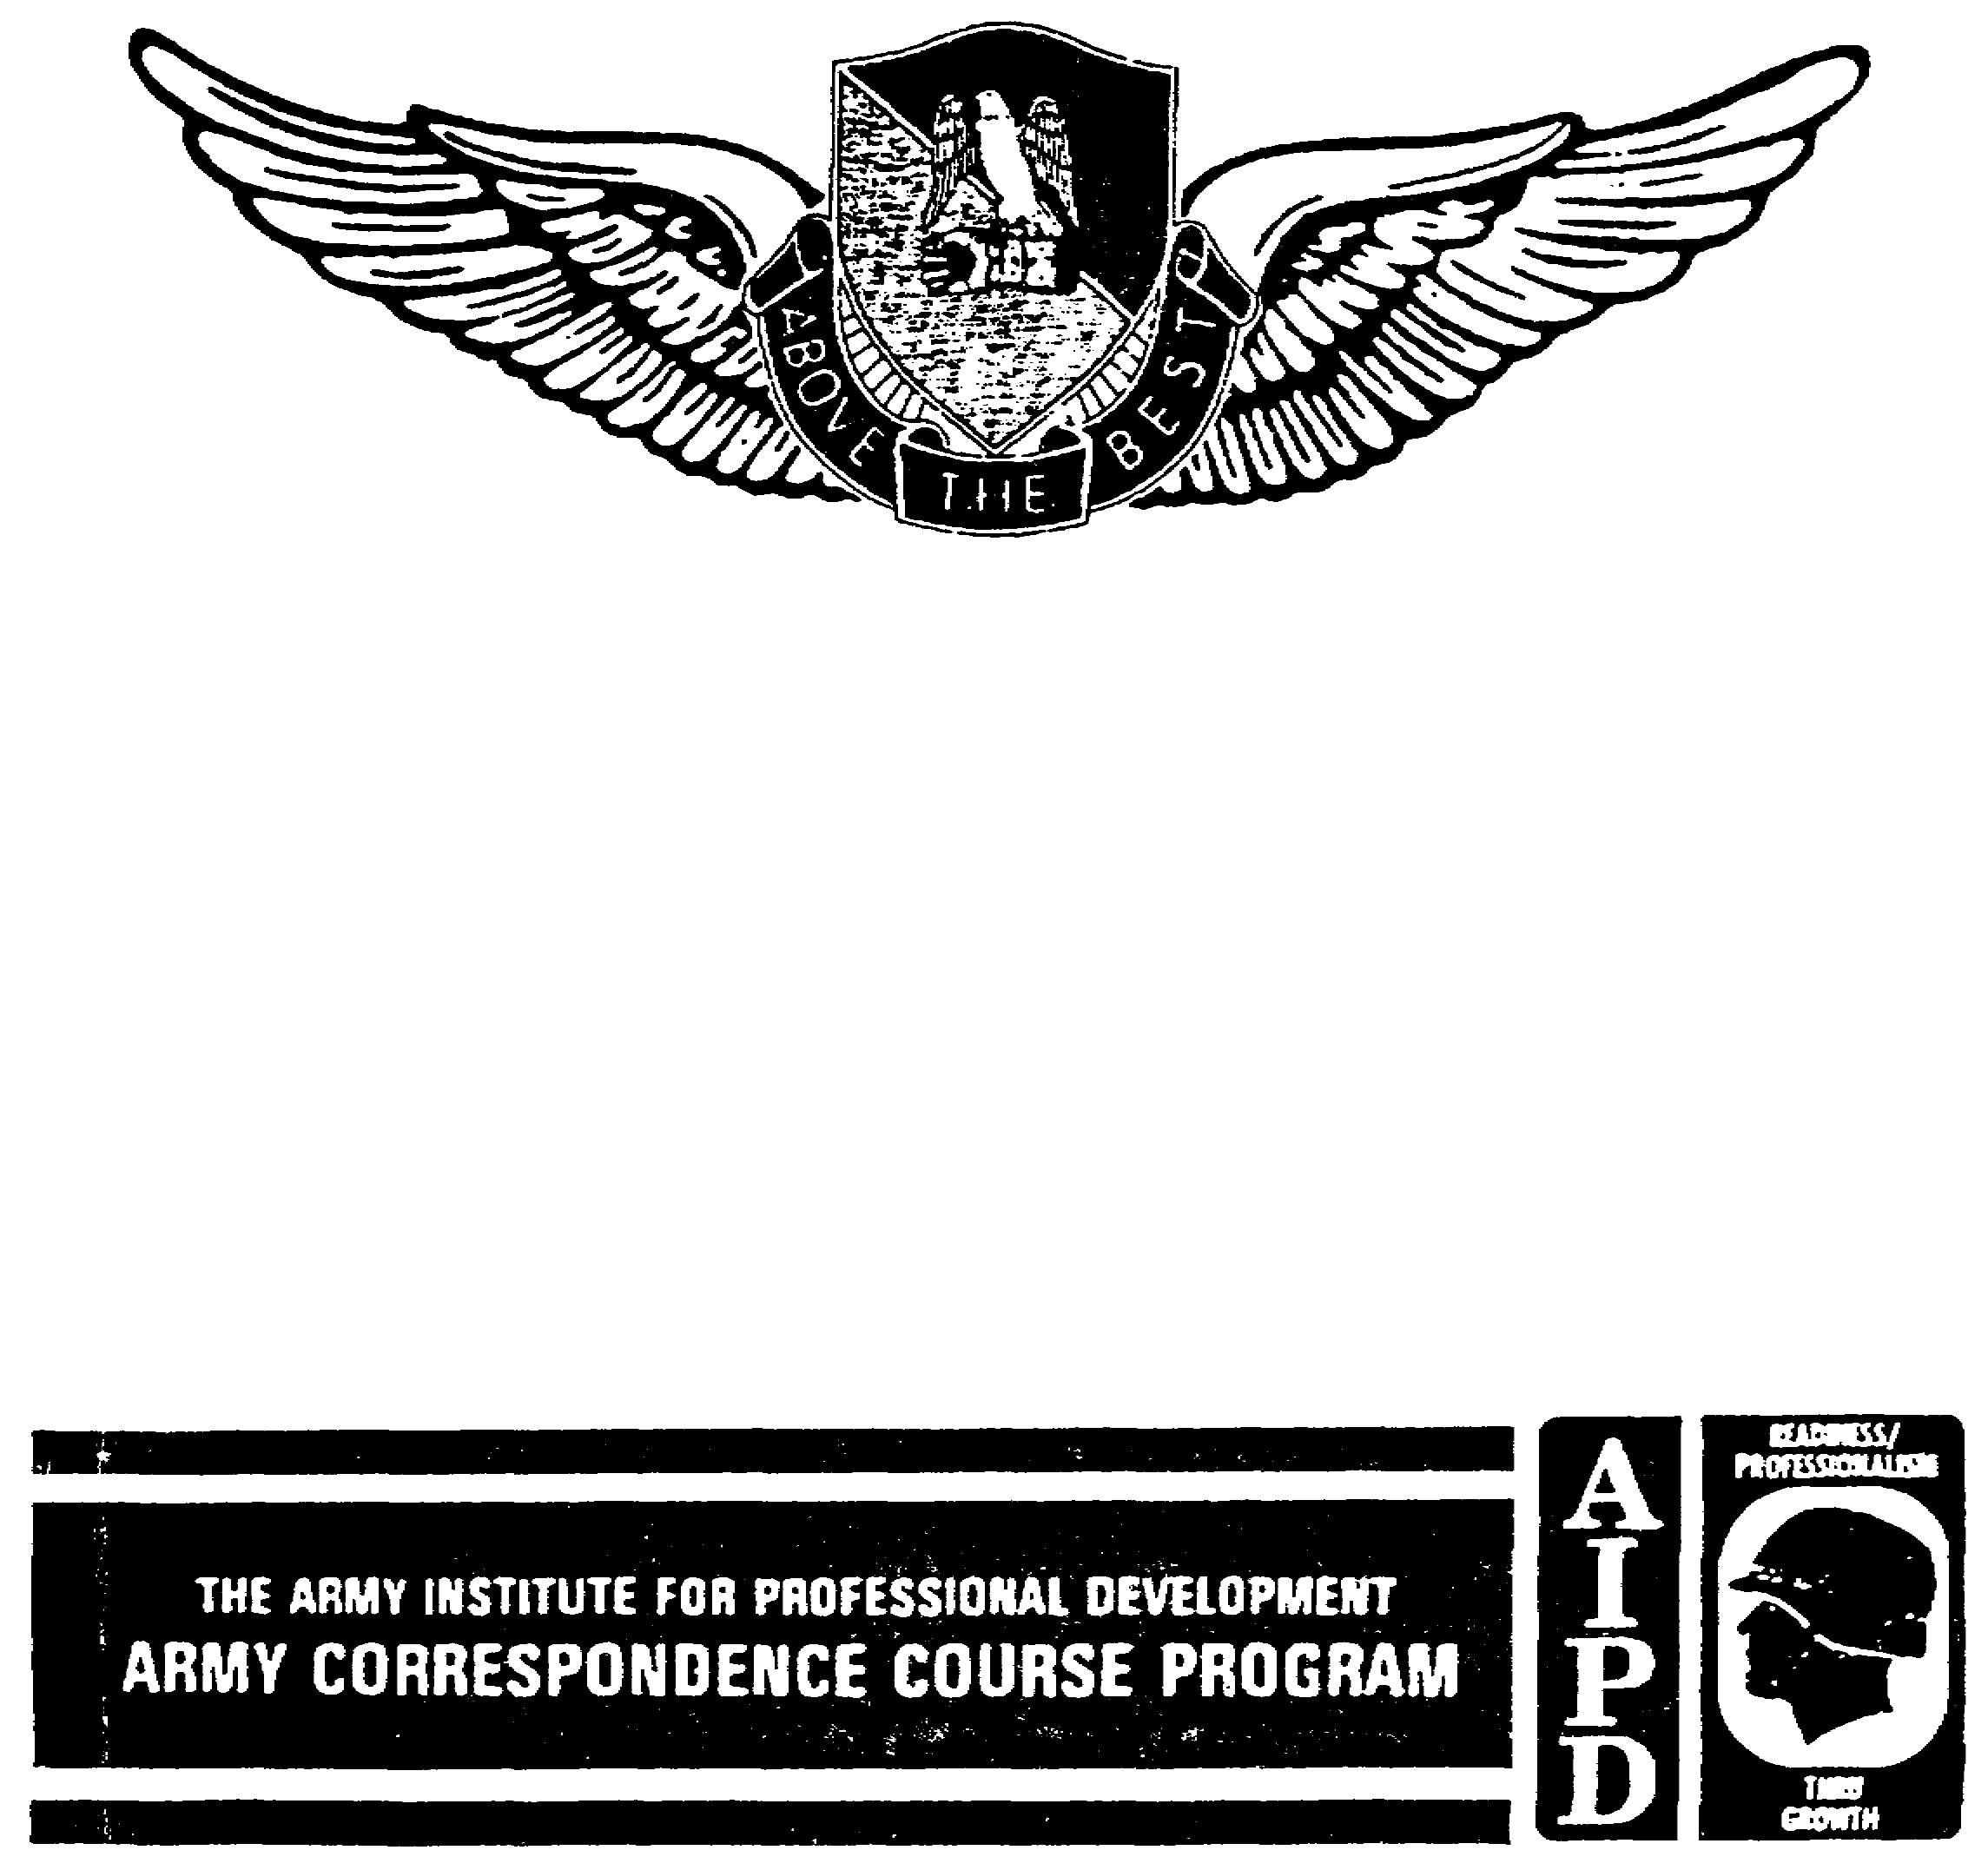

AVIATION PETROLEUM, OIL, AND
LUBRICANT (POL) OPERATION,
MAINTENANCE, AND SAFETY

THIS SUBCOURSE HAS BEEN REVIEWED FOR OPERATIONS SECURITY CONSIDERATIONS.

TABLE OF CONTENTS

Section Page

SUBCOURSE OVERVIEW iv

TERMINAL LEARNING OBJECTIVE iv

LESSON ONE: FUEL SERVICE

OVERVIEW 1

INTRODUCTION 1

Part A. AVIATION FUELS

Aviation Gasoline 2
Turbine and Jet Fuels 4

Part B. FUEL IMPURITIES AND CONTAMINANTS

Contaminants 5
Contamination Detection 6

Part C. FUEL HAZARDS

Fire Hazards 7
Other Sources of Ignition 9

Part D. SAFETY PRECAUTIONS

Fire Prevention 10

Part E. AIRCRAFT DANGERS

Rotor Blades, Tail Blades, and
Propellers 13
Rotor or Prop Wash and Engine
Exhaust 13
Live Armament 13

PRACTICE EXERCISE 15

ANSWER KEY AND FEEDBACK 18

i AV 0550

Section Page

LESSON TWO: EQUIPMENT USE AND STORAGE

OVERVIEW 20

INTRODUCTION 20

Part A. REFUELING EQUIPMENT

Closed-Circuit Refueling Equipment 21
Open-Port Refueling Equipment 22
Forward Area Refueling Equipment 22
Temporary and Semipermanent Refueling
Systems 24
Fuel Tank Vehicles 26
Tank Trucks 29
Tank and Pump Unit 29
Fuel Vehicle Maintenance 30

Part B. POL STORAGE AND HANDLING

Bulk and Packaged Storage 30
Storage and Inspection Procedures
for Storage Areas and POL Yards 30
Serviceability Checks and
Inspections 31

Part C. AIRCRAFT REFUELING

Refueling Procedures 32
Refueling Crew Duties 33

Part D. DEFUELING OPERATIONS

Defueling Methods 39
Defueling Procedures 39
Defueling into a Tank Vehicle 40
Gravity Defueling 40
Defueling Indoors 41
Emergency and Rescue Procedures 41
Warning Signs and Vehicle Markings. 43
Inspecting and Cleaning Fuel Tanks. 44

PRACTICE EXERCISE 47

ANSWER KEY AND FEEDBACK 50

ii AV 0550

AVIATION PETROLEUM, OIL, AND LUBRICANT (POL)
OPERATION, MAINTENANCE, AND SAFETY

Subcourse Number AV 0550
EDITION B

United States Army Aviation Center
Fort Rucker, Alabama 36362-5000

4 Credit Hours

Edition Date: June 1992

SUBCOURSE OVERVIEW

This subcourse provides aviation safety officers with an understanding of the criticality of fuel handling in their units. The course provides information on good safety practices and how to use them in evaluating their own units.

No prerequisites exist for this subcourse.

This subcourse reflects the current doctrine when it was prepared. In your own work, always refer to the latest publications.

Unless otherwise stated, the masculine gender of singular pronouns refers to men and women.

TERMINAL LEARNING OBJECTIVE

ACTION: Conduct an aviation accident prevention survey of an aviation unit with emphasis on aviation petroleum, oil, and lubricant (POL) operation, maintenance, and safety.

CONDITION: Using the US Army Safety Center's Guide to Conducting an Aviation Accident Prevention Survey, the aviation safety officer will conduct a survey of his unit's POL section.

STANDARD: To prove competency of this task, you must achieve a minimum of 70 percent on the examination.

iv AV 0550

LESSON ONE

FUEL SERVICE

Task: NA

OVERVIEW

TASK DESCRIPTION

In this lesson you will learn the types of aviation fuels, their characteristics, the types of contaminants and detection, the hazards associated with their use, and the methods of applying effective countermeasures in the support of the accident prevention program.

LEARNING OBJECTIVE

TASK: You will know the characteristics of aviation fuels to include the types of contaminants, testing requirements, the hazards of use, and the precautions used to prevent injury to personnel and damage to property.

CONDITION: You may use the lesson text and references to complete the Practice Exercise.

STANDARD: You must answer at least 8 of 10 Practice Exercise questions.

REFERENCE: The material in this lesson was derived from the following publications:

AR 703-1.
FM 10-68.
FM 10-70.
FM 10-71.
TB 55-9150-200-24.

INTRODUCTION

All of the Army's aircraft are powered by either gas turbine or reciprocating engines. Although each engine produces power by burning liquid petroleum fuels internally, there is a great difference in the operating principles and fuel requirements of both

1 AV 0550

types. Fuels for Army aircraft fall into two general categories: aviation gasoline (AVGAS) for reciprocating engines and turbine or jet propulsion (JP) fuel for turbine engines. Many turbine-engine aircraft can be serviced with AVGAS as an emergency fuel and can operate efficiently on it for several hours, provided special inspections are performed.

NOTE: TB 55-9150-200-24, Engine and Transmission Oils, Fuels, and Additives for Army Aircraft, the applicable aircraft manual, or both, contain information on these special inspections.

WARNING: Reciprocating-engine aircraft must NEVER be serviced with JP fuel under any condition!

Part A. AVIATION FUELS

Aviation POL operations are more complex and demanding than during the early days of Army aviation. During the Second World War, L-4 Piper aircraft used 12 gallons of fuel for a three-hour flight. By comparison, today's CH-47 requires up to 1,047 gallons for a three-hour flight. It is, therefore, imperative that POL refueling operations remain responsive to the mission requirements.

1. AVIATION GASOLINE

a. Characteristics.

(1) High heat content is measured in British thermal units (BTUs). AVGAS, prepared to conform to MIL-G-5572, is used to power reciprocating-engine aircraft. Although AVGAS is available in three grades, Grade 100/130 is the grade presently used by the Army. The weight of one gallon of AVGAS is six pounds.

(2) The low freezing point is -76 degrees Fahrenheit (ºF) or -60 degrees Centigrade (°C) on all grades at sea level. Any freezing point above this temperature is not acceptable.

(3) Knock value is the resistance of fuel to detonation or compression. The higher the compression ratio, the higher the knock rating. Knocking, the metallic sound heard in a gasoline engine under certain operating conditions, is particularly damaging to the engine. It causes general overheating, piston and cylinder burning, lubrication failure, and power loss. The fuel-air mixture delivered to the cylinders should burn evenly, continuously, and completely.

(4) Volatility is the tendency to evaporate--to change from a liquid to a vapor. AVGAS is considered to be a highly volatile fuel.

2 AV 0550
(5) Vapor pressure is the pressure exerted against the walls of a container by the part of the fuel that has evaporated. Vapor pressure depends on temperature and fuel composition. The relative proportion of components boiling below 100°F (38°C) is especially significant. The Reid vapor pressure test measures fuel volatility.

b. Composition. AVGAS is a mixture of hydrocarbons that boil within the approximate temperature range of 80°F (26°C) to 345°F (172°C). Many hydrocarbons are used either as a raw material or as a blender to produce a satisfactory fuel for aircraft. Sometimes the process includes altering the structures of hydrocarbons.

(1) Tetraethyl lead is a heavy, oily, poisonous, liquid additive. It suppresses the knocking tendency and raises the octane or performance numbers of gasolines.

(2) Tricresyl phosphate (TCP) is an additive in highly leaded fuel. TCP improves spark plug performance by reducing the lead deposits in the combustion chamber that may short spark plug electrodes.

CAUTION: TCP CONCENTRATE HAS A TOXIC EFFECT SIMILAR TO AVGAS IF TAKEN INTERNALLY. If TCP comes in contact with the skin, immediately wash the affected area with soap and water. Take all precautions to prevent inhalation of TCP vapors.

c. Grades and Identification. Each grade of AVGAS is designated by a double set of numbers. The grade 100/130 is the ONLY AVGAS presently available in the Army supply system. The first set of numbers in a grade designation indicates the lean mixture rating (maximum economy). The second set indicates the rich mixture rating (takeoff or maximum power).

(1) Numbers 100 and below are the octane rating and indicate that the knocking tendency of the fuel has been measured in a laboratory test engine and compared with a reference fuel of isooctane or a blend of isooctane and n-heptane. Isooctane has an assigned rating of 100, while n-heptane has a rating of 0. If the fuel being tested has the same knock characteristics as a mixture of 90 percent isooctane and 10 percent n-heptane, the fuel is assigned an octane rating of 90.

(2) Grades above 100 are called performance numbers and are computed mathematically. The performance numbers 100/130 indicate that an engine operating on this fuel could develop 1.00 times more knock-free power at a lean mixture and 1.30 times more knock-free power at a rich mixture than it could from isooctane. Federal law requires that any gasoline containing tetraethyl lead

3 AV 0550

be colored: 100/130 should be green, 80/87 would be red, and 115/145 would be purple.

2. TURBINE AND JET FUELS

a. Characteristics. The characteristics of turbine and JP fuels are similar to AVGAS but have some different properties.

(1) Heat content. Because turbine engines produce power from the rapid expansion of air by high temperature, it is important that turbine fuel produce the highest temperatures possible. By volume, all turbine fuels have a higher heat content than AVGAS.

(2) Volatility. Turbine engines can operate efficiently on low volatile fuels; however, starting engines especially at low temperatures may be more difficult. Army aircraft generally use a highly volatile fuel because engines must often be started without the aid of external power units.

(3) Composition. Turbine and JP fuel are mixtures of hydrocarbons and are categorized as either gasoline or kerosene types. JP fuels contain no tetraethyl lead or dyes: all types are a light straw color.

b. Grades of Turbine Fuels.

(1) JP-4 is the primary fuel used in Army turbine engine aircraft. JP-4 is a mixture of approximately 65 percent gasoline and 35 percent light petroleum distillate. Its freezing point is -72°F (-58°C), and it weighs 6.5 pounds per gallon. Commercial grade Jet B is equivalent to JP-4 except that its freezing point is -56°F (-49°C). JP-4 must settle for one hour per 12-inch depth of the storage container before the fuel can be tested.

NOTE: DOD-procured JP-4 contains a fuel system icing inhibitor that prevents the water in fuels from freezing. Liquid dye additives are also available to detect leaks in aircraft fuel systems.

(2) JP-5 is the alternate fuel for use in most turbine engine aircraft. JP-5 is specially refined kerosene and has a very low volatility. Commercial fuels Jet A and A-1 are similar to JP-5 except for their freezing points.

4 AV 0550

Part B. FUEL IMPURITIES AND CONTAMINANTS

Any unit or organization that possesses military fuel is responsible for establishing and maintaining an adequate quality surveillance program.

3. CONTAMINANTS

a. Sediment. Sediments are contaminants from tanks, pipes, pumps, air, hoses, and people. The most common elements of sediment found in AVGAS are bits of rust, paint, dust, sand, metal, and rubber. Sediment is classified by particle size.

(1) Coarse sediment. Particles classified as coarse are 10 microns or larger (25,400 microns = 1 inch). Coarse sediment settles out of fuels quite easily and can be removed by adequate filtering. Particles of coarse sediment clog nozzle screens, fine screens throughout the aircraft fuel system, and more importantly, the engine fuel orifices. Coarse sediment can also become wedged in sliding valve clearances and valve shoulders where it causes excessive wear in fuel control and fuel metering equipment.

(2) Fine sediment. Particles classified as fine are smaller than 10 microns. Removing fine sediment by settling or filtering is effective only to a limited degree. Fine sediment can, however, be removed by centrifuge. Fine sediment accumulates in fuel controls and forms a dark, shellac-like surface on the sliding valves. It can also form a sludge that causes sluggish fuel metering. Fine sediment particles are not visible to the unaided eye, but they do scatter light. Fine sediment may be observed as point flashes of light or a light haze in the fuel.

b. Water. Either fresh or salt water may be dissolved or free within the fuel. Dissolved water has been absorbed by the fuel. It cannot be seen or separated out of the fuel by filtration or mechanical methods. The inherent danger of dissolved water is that it settles out as free water as the fuel is cooled, such as at high altitudes. Free water can be observed in fuel as droplets, a cloud, an emulsion, or in large amounts in the bottom of a tank, filter-separator, or sample bottle. Free water can freeze in the aircraft fuel system and corrode the components of the aircraft fuel system. Ice in an aircraft fuel system can make the engine fail. Free water can be removed from fuel by adequate filtering.

c. Microbiological growth. Microbiological growth is the growth of living organisms (fungi, protozoa, or bacteria) wherever there are pockets of water in fuel tanks. If there is no water in the fuel, microbes cannot grow. Microbiological growth contaminate fuel, hold rust and water suspended in the fuel, and

5 AV 0550

act as stabilizing agents for fuel and water emulsions. These suspensions cling to glass and metal and may cause false fuel quantity readings. They also cause fuel controls to operate sluggishly and make fuel flow dividers stick. Microbiological growth is a reliable indication that fuel filers have failed and that water was not strained from the fuel. The addition of icing inhibitors to JP-4 has helped curb the growth of microbes; however, removing all water from aviation fuels remains extremely important.

d. Commingled fuels. Commingling is the mixing of two or more products or grades of products. Since each aircraft is specifically designed to operate on a particular type and grade of fuel, the consequences of mixing fuels can range from minor performance variations to a total loss of engine power.

4. CONTAMINATION DETECTION

a. Laboratory Testing. No person should be permitted to draw an aviation fuel sample unless they are thoroughly familiar with sampling techniques. Laboratory tests are made to ensure that fuel quality meets specifications and to identify unknown products and potential causes of contamination. Fuel samples will be submitted for testing according to Tables II, III, IVa, and IVb of the Military Handbook 200 (latest revision).

b. Unit or Organizational Testing. The scope of testing accomplished at unit level is limited by the availability of testing equipment and by the short time frame in which results must be obtained. Testing is oriented to identifying the fuel and the most common forms of contamination. Fuel supplies at unit level must be tested to detect the presence of water-fibrous materials and to confirm their identities.

(1) American Petroleum Institute (API) gravity test. The gravity test is used in conjunction with a visual check (differentiation by color). This test measures the API gravity range for each type and grade of fuel. The API gravity test confirms the color identification. Confirmation is necessary because the dyes used in fuels may lose color with age or when subjected to heat. The API gravity test measures the fuel uniformity, not the quality.

(2) Aqua-Glo Test (water detection). Water detection in aviation fuels is accomplished with the automotive or aviation fuel water detector kit commonly called the Aqua-Glo kit. Aviation fuels are unacceptable for use if they contain more than 10 parts per million (ppm) of water. The Aqua-Glo test is essentially a check to see if the filter-separator is functioning properly. If more than 10 ppm of water are found in the sample, the filter-separator has failed, there is a malfunction in the

6 AV 0550

system, or the fuel does not meet specifications. The fuel in a system or refueler must be sampled and tested daily for water at the start of aircraft refueling operations and again when the filter elements of the filter-separator on the system or refueler are changed.

(3) Fibrous material. Fuels samples should contain not more than 10 fibers when a quart sample is visually examined.

c. Contaminated Fuel. In the event fuel is found to be contaminated or is suspected to be contaminated, that fuel must be segregated and samples must be sent to the laboratory for further testing. Under no circumstance should that fuel be introduced into any system or aircraft. That system or aircraft found to have been contaminated or suspected to be contaminated will be put out of service until such time that contamination is found to have not occurred or the system has been defueled, cleaned, and retested.

Part C. FUEL HAZARDS

Handling aviation fuel is extremely dangerous for a variety of reasons. People who service aircraft and others who handle volatile fuels are constantly surrounded by health, fire, and explosion hazards. The lives of pilots, crew members, and passengers are endangered when incorrect or contaminated fuels are dispensed to aircraft. The lives and health of fuel handlers also-may be jeopardized through its mishandling. Each individual who works with or comes in contact with POL products must be informed of the real and potential hazards associated with its use and handling.

5. FIRE HAZARDS

The ease with which a fuel ignites depends on its physical properties and characteristics.

a. Flash Point. The flash point of a fuel is the lowest temperature at which a fuel's vapors will catch fire momentarily (flash) when exposed to a flame. The flash point of AVGAS is approximately -50°F; JP-4 is -10°F. The practical meaning of these flash points is that AVGAS and JP-4 will give vapors capable of igniting at the normal range of temperatures and pressures in which Army aviation units operate.

b. Volatility. The volatility of aviation fuels (or any petroleum product) is the ease with which it passes from the liquid to the gaseous state. On a hot day vapor waves can actually be observed pouring from an open fuel tank. The vapor appears to be rising in the air but only because it is being

7 AV 0550

pushed out under pressure (the vapor pressure of the fuel). Gasoline vapor does not rise; it sinks to the ground because it is heavier than air. Gasoline vapor follows downhill slopes, occupies holes and depressions, and remains for some time because of its density. Vapor need not be ignited at the point of escape to be dangerous; it can be ignited at a distance and flame back to the point of escape. This flashback can be disastrous to anyone in its path. Simple combustion takes place when the vapor burns in the open air, but an explosion may occur in a confined space, such as a room or a tank.

c. Flammability Limits. The flammability limits of fuel are the limits within which a vaporous fuel-air mixture will ignite if sufficient heat is present. Mixtures of fuel vapors below the lower flammability are too lean to burn, while mixtures above the upper flammability limits are too rich to burn. Flammability limits for AVGAS are between 1.4 and 7.6 percent AVGAS vapor by volume (between -50°F and +30°F) and 0.8 and 5.6 percent for JP-4 (between -10°F and +100°F). For practical purposes, this means that in most places JP-4 is within the flammable range and, additionally, AVGAS is cause for concern in cold climates. In aircraft accidents, an unusual phenomenon may occur. A fuel mist (a fog of fuel droplets and air) may form if fuel tanks rupture on impact. Extreme caution must be used around a fuel mist because it is as dangerous as a vapor-air mixture in terms of reaching the flammability limits of fuel.

d. Vapor Pressure. The vapor pressure of a fuel is the pressure of the vapor at any given temperature at which the vapor and liquid phases of the fuel are in equilibrium in a closed container. Vapor pressure is a measure of the volatility of fuel. AVGAS and JP-4 give off flammable vapors at normal temperatures and pressures.

e. Autoignition Temperature. The autoignition temperature of a fuel is the lowest temperature at which it will catch fire spontaneously, independent of any other source of ignition. AVGAS autoignites at temperatures between 824°F and 960°F. On the other hand, JP-4 autoignites when it reaches between 470°F and 480°F. When a helicopter engine is idling (as in hot refueling), its temperature is 470°F to 500°F. Even after shutdown, a jet engine remains in this temperature range for some time. It is not hard to imagine the results if this heat were to radiate to the JP-4 in the fuel system.

f. Electrostatic Susceptibility. The electrostatic susceptibility of a fuel is the degree to which fuel will take on or build up a charge of static electricity. The amount of charge that will build up depends on the type of fuel, amount and kind of impurities, and the rate of flow. JP-4 has a greater capacity

8 AV 0550

to retain impurities and, as a result, will build and hold a static charge more easily.

6. OTHER SOURCES OF IGNITION

a. Static Electricity. This term is used to define the buildup of an electrical charge that occurs when an aircraft moves along the ground or through the air, when fuel rubs against unlike materials as it does during refueling, or from the air moving across the aircraft as it sits idle. If air contains impurities (dust, snow, water, or ice), even more of a charge is created. Electrons are exchanged or redistributed between two materials at the point where they touch. This exchange of electrons causes unlike but equal charges on the two materials that attract each other as they seek equilibrium. If the attraction is strong enough, it may jump the gap to the other surface in its search for equilibrium. This spark, or impulsive discharge of electricity, is a real danger in a refueling operation.

b. Static Electricity From Personnel and Clothing. The human body conducts electricity. In dry climates, a person can build and hold several thousand volts when walking on rugs or in certain manufacturing operations. Normally, clothes and footgear are moist enough to drain off these charges as quickly as they develop. Outer clothing, especially if made of wool or some synthetic fibers, builds up charges by absorbing them from the body and by rubbing against the body and underwear. When charged clothing is moved away from the body or taken off, the electrical voltage increases to the danger point. This is why it is important not to try to remove fuel soaked clothing without first wetting them down completely. The chances of igniting the fuel are greatly enhanced, and personal injury can occur.

c. Lightning. Lightning is a massive discharge of static electricity that builds up in a highly electrified storm cloud. In addition to the danger of a lightning strike, nearby lightning may suddenly release stored aircraft charges that are insulated from the ground.

d. Other Equipment. The fuel handler should always be aware of other operations around him during a fueling operation. Other personnel and equipment may become a source of ignition. Open flames, hot engines, and electrical equipment can be the cause of fuel ignition. In the event of any possible danger of ignition, the fueling operation should be stopped and service ports closed until the operator is sure that the danger has passed.

9 AV 0550

Part D. SAFETY PRECAUTIONS

7. FIRE PREVENTION

Careful equipment operation and attention to detail will prevent most fires. Everyone engaged in refueling must know how to stop the fuel flow in an emergency and be prepared to do so. Stopping the fuel flow is the first consideration in case of fire. Control and shutoff valves must NOT be left unattended during refueling or fuel transfer operations. Refueling operations must be carried out to eliminate or reduce spills, splashes, and overflows. All leaking pipe joints or hose and nozzle connections, as well as other damage to the fueling system, must be reported at once. Listed below are specific steps that should be taken to prevent or reduce the fire hazards of aviation fuels.

a. Trap the Vapors. One of the main hazards in refueling operations is the presence of flammable vapors. To control the fire danger, the closed-circuit refueling system has been developed. This system prevents the escape of vapors at the aircraft fill port, reducing the danger of ignition from static electricity or engine heat. In the closed-circuit refueling system, the fuel vapors escape through the tank vent under the aircraft and are dissipated by the rotor wash.

b. Bonding. Bonding is the process through which two conductive surfaces are joined together to minimize their potential differences. Bonding does not dissipate the static electricity, but it equalizes the charges on two unlike objects. Bonding precludes arcing, thereby reducing the risk of ignition. During refueling operations, the refueling nozzle must be bonded to the aircraft before removing the dust or tank cap so any spark will occur before fuel vapors are present.

c. Grounding Rods. The use of grounding serves to dissipate the electrical charges. The required depth of the ground rods are shown in the Figure. By grounding aircraft, fueling systems, and equipment, you greatly reduce the chance of a spark as an ignition source.

(1) Rod inspection. Each rod must be inspected when it is installed. Ground wires are inspected daily. The grounding system must be tested annually or when there is the possibility of mechanical damage.

(2) Marking grounding rods and points. Semipermanent and permanent ground points will be labeled with a yellow circle 18 inches in diameter with a 2-inch black border. This marking will encircle each grounding rod that is installed on a hard surface. Use paint for marking a hard surface ground point;

10 AV 0550

plastic or metal discs may be used for grounding rods in soft surfaces.

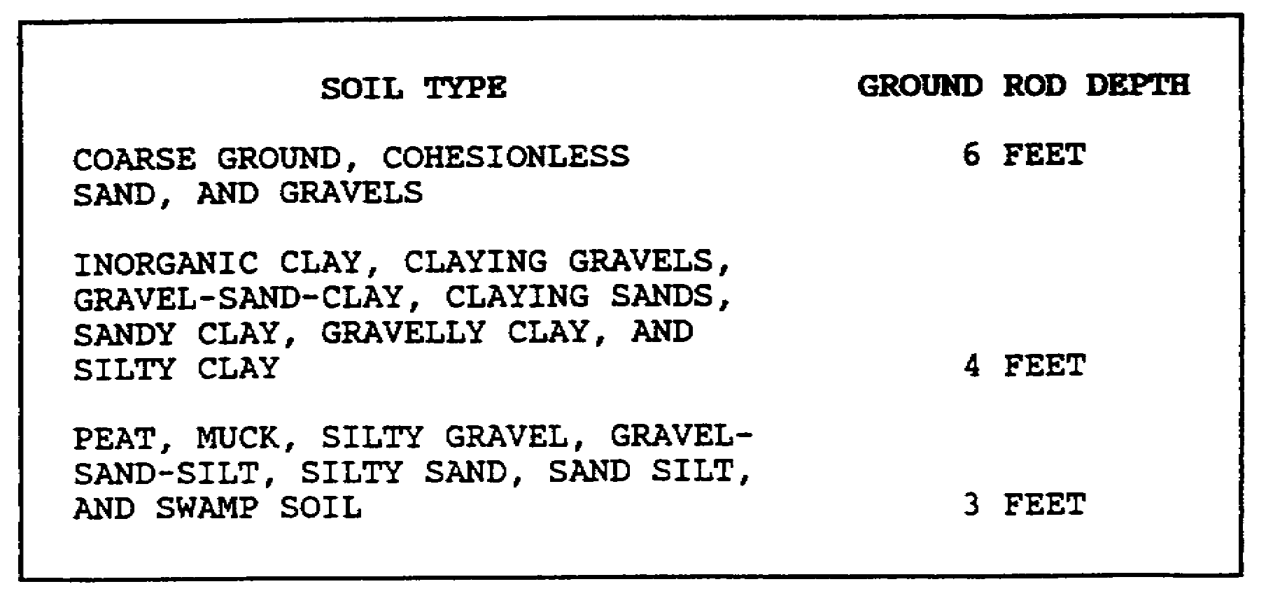

Figure. Ground Rod Depths.

(3) Electrical resistance. The electrical resistance of each grounding system should be as low as possible. Ten thousand ohms resistance is maximum for grounding points. Records must be kept for permanent and semipermanent airfields, showing identification of each ground point, the date tested, and its resistance in ohms. Such records are not required at temporary refueling points.

d. Personnel. To reduce sparking from personnel, refuelers should bond themselves to the refueling system or container by taking hold of it before opening a fuel port in order to equalize the potential differences to a safe level.

e. Vehicles. Fuel builds up a charge as it is recirculated or when samples are taken. Therefore, all vehicles must be properly bonded and grounded when they are parked.

f. Personnel Protection. To ensure the safety of all personnel involved in fuel handling, use the following protective clothing:

(1) Uniform. Currently no special uniform has been developed for personnel who handle aviation fuels. The standard refueling uniform is the battle dress uniform. Some units require that the nomex flight suit be used by fuel handlers.

11 AV 0550

(2) Helmet. Refueling personnel will wear the SPH-4 flight helmet with the visor down (when available). The helmet provides protection from flying debris and allows communication with the crew during refueling. The SPH-4 also provides some hearing protection. If the SPH-4 is unavailable, an approved motorcycle helmet and goggles may be used.

(3) Earplugs. Earplugs will be worn by all personnel to reduce the chance of hearing loss during exposure to continuous high noise levels.

(4) Gloves. Leather or flame-retardant gloves will be worn to protect the hands from fuel exposure. When gloves become fuel soaked or torn, they should either be cleaned or discarded.

(5) Footwear. Standard, rubber-soled, all-leather, combat boots will provide adequate foot protection. Remove metal taps or cleats. Repair any worn surface with bare shoe nails. Metal on the soles of boots could cause a spark against a hard surface on the ground. Avoid heavy rubber cleats as they may pick up and carry a foreign object onto the flight line. If this happens, the object may come loose and be flung by rotor wash or be sucked into aircraft engines.

(6) Clothing. Roll down and button shirt sleeves. Secure loose items of clothing to prevent entanglement in moving equipment. Do not wear jewelry, such as rings, as they may catch on moving parts. Secure objects (pens, pencils, and combs) to avoid their ingestion into the operating system or becoming lethal missiles. Metal objects should be of nonsparking material (brass) to prevent a source of ignition if dropped.

(7) Water. Keep enough water on hand to wet the fuel handler if fuel spills on his clothing.

(8) Protective mask. Fuel handlers exposed to AVGAS or JP fuels should wear a protective face mask with proper filtering. Inhalation of these fumes can be toxic.

Part E. AIRCRAFT DANGERS

Operating in and around aircraft poses several dangers other than those with just fuel handling. Rotor blades, tail rotor blades, propellers, rotor or prop wash, engine exhaust, and live armament systems pose threats to safety and must be considered by the aviation fuel handler.

12 AV 0550

8. ROTOR BLADES, TAIL BLADES, AND PROPELLERS

Rotor blades droop when operating at slow speed, so there is less clearance at the tips. Be especially careful when approaching or leaving a helicopter if there is a rise or slope to the ground. The rotor blade may be much closer to the ground on the upslope side of the aircraft. The tail rotor may be as low as 1 1/2 feet off the ground, and the pilot cannot see the tail of his helicopter. Always move around the nose of the aircraft, NEVER around the tail. Propellers of fixed-wing aircraft become nearly invisible when moving. Always approach with extreme caution any aircraft with turning engines, and watch the aircrew for any signals they may give you.

9. ROTOR OR PROP WASH AND ENGINE EXHAUST

Rotor or prop wash can cause serious damage or injury if trash or debris is blown around. Make sure your refueling points are kept clean. Temperatures from exhausts and exhaust vents of idling turbine engines can reach 470°F to 500°F.

10. LIVE ARMAMENT

Aircraft will have all armament placed in the safe position to avoid accidental firing or discharge; however, fuel handlers should never walk in front of any weapon system or touch any armament. (The Gatling type of cannon can be caused to fire by rotating the barrels.) In addition when positioning aircraft with weapons systems, you should have systems pointed in a safe direction--away from personnel, buildings, equipment, and fuel storage if at all possible.

13 AV 0550

LESSON ONE

PRACTICE EXERCISE

The following items will test your grasp of the lesson material. Each item has only one correct answer. When you complete the exercise, check your answers with the answer key that follows. If you answer any item incorrectly, restudy that part of the lesson.

1. Reciprocating engines should be fueled with what type of fuel?

A. JP-4
B. Jet-A
C. kerosene
D. 100/130 AVGAS

2. The use of tetraethyl lead is important in AVGAS because it

A. helps turbine engines achieve better fuel economy.
B. prevents lead deposits on the cylinder walls of the engine.
C. suppresses the knocking tendency and raises the octane numbers.
D. helps to lower the performance levels to engine requirements.

3. The use of ground wires and rods

A. prevents static electricity.
B. eliminates the need for bonding.
C. helps dissipate static electricity.
D. MAY NOT be necessary in fueling areas.

4. JP-4 is

A. hard to ignite at air temperatures below 100°F.
B. very stable and presents few hazards to fuel handlers.
C. rarely within its flammable range and can be easily transported.
D. within its flammable range most temperatures in which the Army operates.

15 AV 0550

5. Units detect water in aviation fuels by using the

A. visual check.
B. milipore test.
C. Aqua-Glo test.
D. API gravity test.

6. Sediment in fuel consists in part of

A. fungi.
B. paint.
C. water.
D. protozoa.

7. Fuel samples from a refueler are required when the filter-separator is first placed in service, then

A. weekly.
B. monthly.
C. biweekly.
D. daily before the start of refueling operations.

8. Fuel vapors are

A. lighter than air.
B. heavier than air.
C. of little hazard.
D. dissipate rapidly.

9. Permanent or semipermanent grounding systems should

A. be tested weekly.
B. not be inspected.
C. be tested annually.
D. be tested biannually.

10. When installing a grounding rod in claying sand, you should drive the rod into the ground how many feet?

A. three
B. four
C. five
D. six

16 AV 0550

LESSON ONE

PRACTICE EXERCISE

ANSWER KEY AND FEEDBACK

Item Correct Answer and Feedback

1. D. 100/130 AVGAS

This is the only AVGAS fuel in the Army system. JP-4 and JP-5 are turbine fuels. Kerosene is a part of turbine fuel. None should be introduced into the reciprocating engine. (page 1, INTRODUCTION, and page 2, WARNING)

2. C. suppresses the knocking tendency and raises the octane numbers.

Tetraethyl lead raises the octane level of fuel. [page 3, para 1b(1))

3. C. helps dissipate static electricity.

Grounding rods provide a path of static build up to follow to the ground. (page 10, para 7c)

4. D. within its flammable range at most temperatures in which the Army operates.

JP-4 is within flammability range at temperatures of -10°F to 100°F, the operating range of most Army units. (page 8, para 5c)

5. C. Aqua-Glo test.

The Aqua-Glo kit is designed to detect the presence of water in aviation fuels. [page 6, para 4b(2))

6. B. paint.

Paint, rust, dust, sand, and rubber are considered sediments; the others listed are forms of microbiological growths. (page 5, para 3a)

7. D. daily before the start of refueling operations.

Before any aircraft refueling operations begin, the fuel in the tanker must be tested for water contamination. [page 6, para 4b(2) ]

18 AV 0550

8. B. heavier than air.

Fuel vapors follow down hill slopes; AVGAS does not rise. (page 7, para 5b)

9. C. be tested annually.

Grounding systems must be tested annually. [page 10, para 7c(1) ]

10. B. four

The grounding rod should be driven into the earth below the permanent ground moisture level estimated at 4 feet. (page 11, Figure)

19 AV 0550

LESSON TWO

EQUIPMENT USE AND STORAGE

Task: NA

OVERVIEW

TASK DESCRIPTION

In this lesson you will learn to recognize the correct procedures and standards for POL equipment use, storage, and operations.

LEARNING OBJECTIVE

TASK: You will know the proper POL equipment utilization requirements, storage requirements, and operational procedures needed to support the accident prevention program.

CONDITION: You may use the lesson text and references to complete the practice exercise.

STANDARD: You must answer correctly at least 8 of 10 practice exercise questions.

REFERENCE: The material in this lesson was derived from the following publications:

AR 703-1.
FM 10-68.
FM 10-70.
FM 10-71.
TB 55-9150-200-24.

INTRODUCTION

In aircraft refueling operations, equipment use and safety policy are interrelated. The type of equipment used influences the safety procedures required for safe and efficient refueling operations.

20 AV 0550

Part A. REFUELING EQUIPMENT

1. CLOSED-CIRCUIT REFUELING EQUIPMENT

a. Closed-Circuit Nozzles. Any closed-circuit refueling (CCR) system depends on two basic pieces of equipment: a receiver that is mounted on the aircraft and a nozzle. These two pieces are designed to mate or lock together before fuel can flow through them.

b. Closed-Circuit Refueling Port. The CCR port is built into the aircraft. The port includes a float-operated valve that controls the fuel flow into the aircraft's tanks at a fixed rate. The valve closes at a certain level and automatically shuts off when a certain level is reached. Additionally, the valve closes if the fuel rate exceeds that of the aircraft's maximum safe flow rate. A bypass opening is positioned inside the receiver. When the bypass opening cover is pushed aside, it is possible to refuel an aircraft with a conventional automotive-type nozzle.

c. Closed-Circuit Refueling Nozzle. The CCR nozzle mates with the CCR receiver on the aircraft. Once the nozzle is properly inserted into the receiver, it is mechanically locked into place. A pull on the latch release lanyard valve in the nozzle prevents fuel from accidentally flowing until it is properly mated with the receiver, then it allows fuel to flow through the nozzle. The CCR nozzle can be operated at flow rates of up to 150 gallons per minute (gpm). The nozzle incorporates a pressure regulator that limits fuel pressure to 15 pounds per square inch (psi) at the point of connection to the receiver. A removable inlet assembly unscrews so that a 100-mesh wire cloth strainer between the nozzle inlet and the coupling can be cleaned. In larger refueling operations when more than one product is used, the nozzle should be marked with the product being dispensed.

d. Open-Port (Gravity-Fill) Nozzle Adapter. An open-port (gravity-fill) nozzle is available to service an aircraft using the open-port refueling method. The adapter locks onto the discharge end of the CCR nozzle and has a squeeze-type trigger grip that opens and closes the flow control valve of the adapter. (The flow control valve of the CCR nozzle itself must be opened Before the fuel can flow.) Additionally, the nozzle adapter can be used in an unusual circumstance if it is necessary to bypass the CCR system.

EXAMPLE: If it will not be possible to pump through the CCR system, the adapter can be mated to the CCR nozzle and used to pump fuel through the bypass opening in the receiver.

21 AV 0550

2. OPEN-PORT REFUELING EQUIPMENT

a. Open-Port Refueling. Open-port refueling is much the same as filling a truck or car; an automotive type nozzle is inserted into an open fuel port. Most of the Army's nozzles are designed for open-port refueling. The drawbacks of this system are that it is susceptible to contamination, allows fuel vapors to escape through the port, and is subject to overfilling and spills.

b. Open-Port Nozzles. The Army has three standard nozzles used for aircraft refueling: 1-inch, 1 1/2-inch, and 2 1/2-inch automotive-type. The standard Army overwing nozzle is an open-port nozzle equipped with a ring-shaped bumper that prevents it from going too far into a fill port mounted in the wing. This bumper can be removed to allow the nozzle to be used with a fill port on the fuselage.

c. Aircraft Refueling Hoses. For safety reasons, hoses used for aircraft operation must be in good condition and should be inspected before use. If tears, bulges, blisters, or soft spots are noticed, replace the hose. If during normal operation any leaks or bulges are noted, discontinue operations and replace the hose. Hoses that are of sufficient length may be repaired and after testing returned to service.

NOTE: Hydrostatic testing of hoses, other than sea hoses and cargo hoses, is not required.

3. FORWARD AREA REFUELING EQUIPMENT

a. Unit level refueling operations are characterized by rapid, closed-circuit, hot refueling conducted in a forward area under combat or simulated combat conditions. To accomplish this mission, a lightweight, air-transportable, refueling system known as the forward area refueling equipment (FARE) system was developed. Utilizing trained personnel, a FARE system can be fully operational within 15 minutes of delivery to a site (Figure 2-1).

(1) Equipment. The FARE system is made up of a pumping assembly, a filter-separator, hoses, nozzle, grounding equipment, and valves and fittings. Apart from the FARE system are fire extinguishers and a fuel source.

(2) Pumping and filter separator. The pumping assembly consists of a 100-gpm centrifugal pump and a two-cylinder, four-cycle, three-horsepower engine housed in a tubular aluminum frame with an eight-foot grounding cable. The filter-separator is also mounted in a tubular frame with a grounding cable. The filter-separator is an aluminum tank with a removable cover. Five filter elements, each in a canister, are set in a mounting plate

22 AV 0550

near the bottom of the tank. The filter-separator has an air vent valve, a pressure differential indicator, a water sight glass with float indicator, and a manually operated water drain valve. It is equipped with a pressure differential indicator that tells when to change the filter elements. When readings are in the green (-20 psi), elements are clean; if reading is in the 20-35 psi range of the yellow arc, elements should be changed at the end of the day. If the reading is in the red (+35 psi), the elements should be changed immediately.

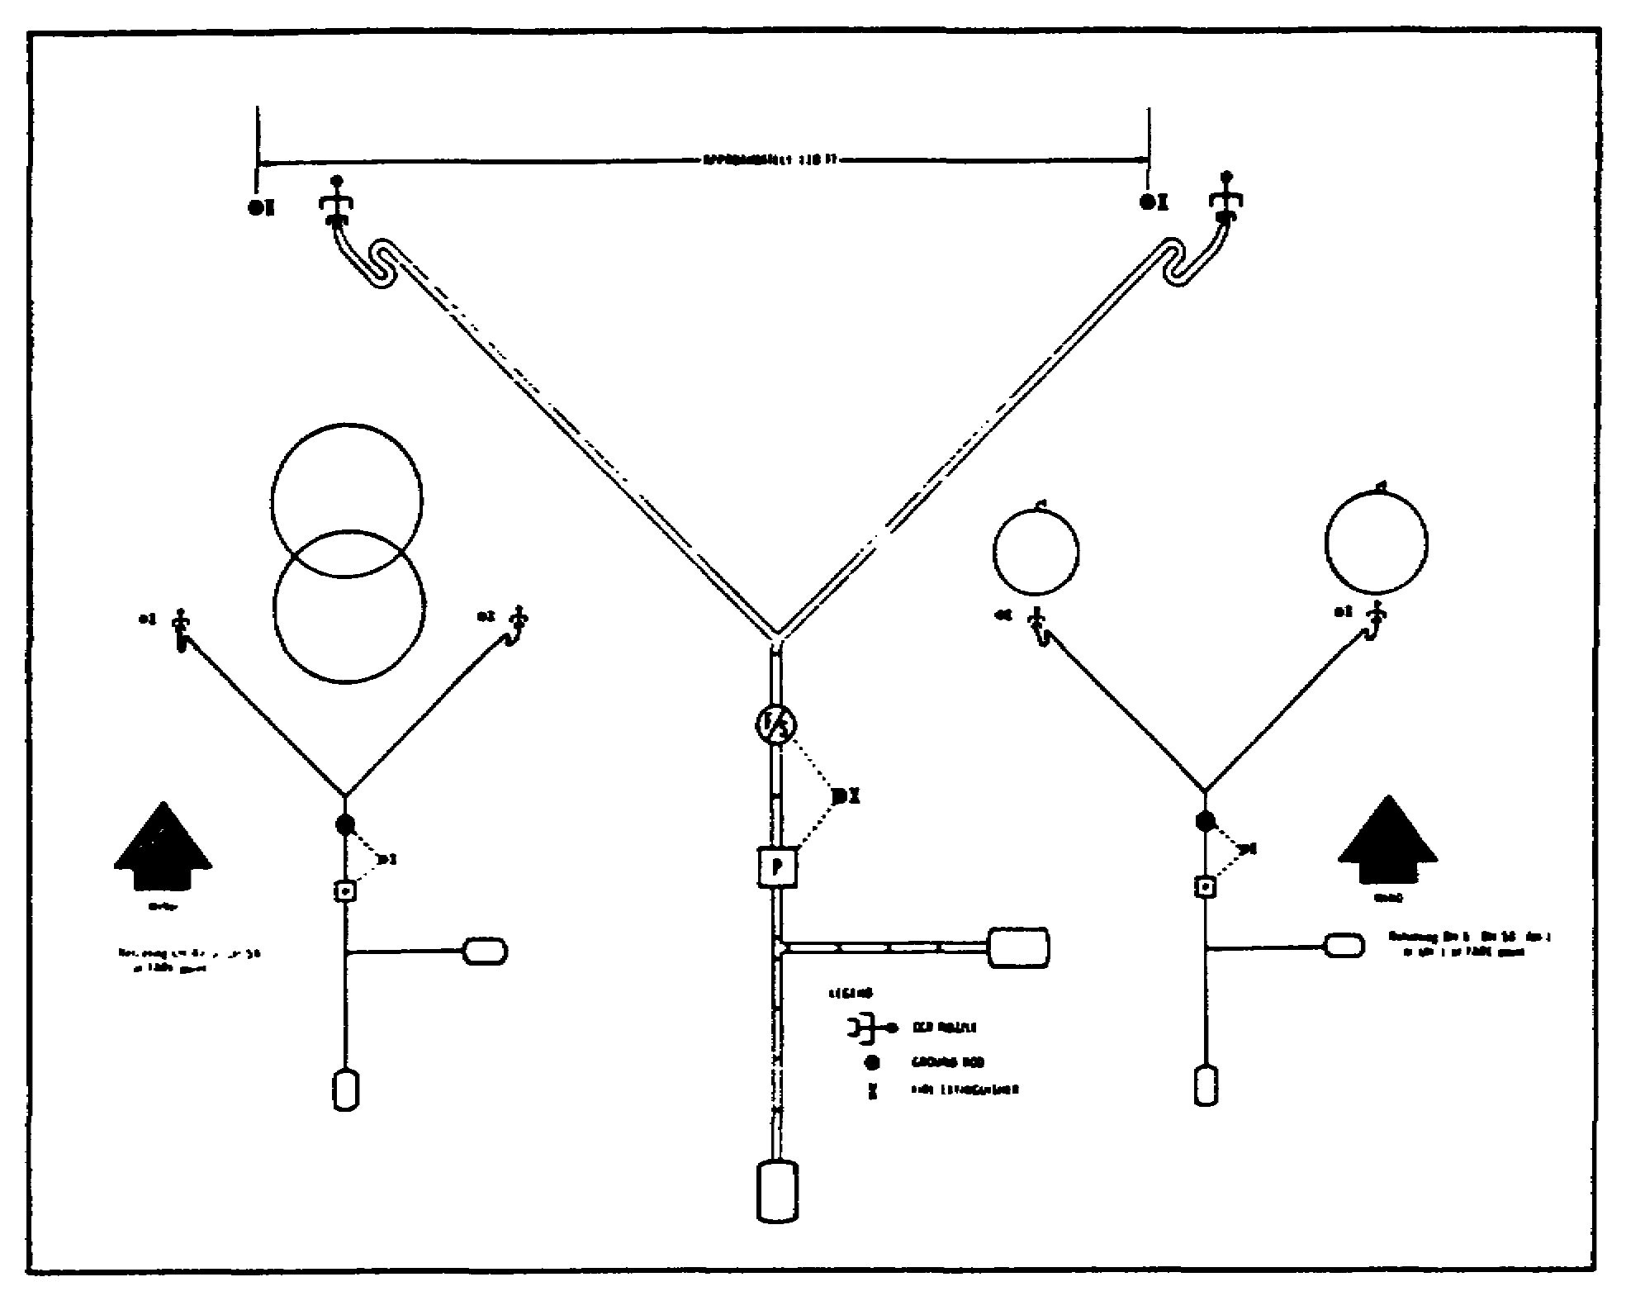

Figure 2-1. Typical Layout of a Four- or Five-Point FARE System.

(3) Discharge hoses and fittings. The FARE system has two sets of discharge hoses, their fittings, and nozzles. Each set is mounted in a tubular aluminum frame.

23 AV 0550

(4) Suction hoses and fittings. Two canvas carrying cases hold the suction hoses and their fittings. These two sets include 12 five-foot lengths of suction hose and grounding rods.

4. TEMPORARY AND SEMIPERMANENT REFUELING SYSTEMS

When demand exceeds the capacity of the FARE system, the construction of a temporary or semipermanent system is justified. Using components from the dual system supply point (a refueling point with greater capacity and flow) can be established. This system may take hours to construct and will be harder to conceal from hostile forces (Figure 2-2).

a. Equipment. Standard POL handling equipment is used to assemble a temporary refueling system. The amount of equipment needed depends on the planned use of the system as well as the number and type of aircraft to be serviced. The basic equipment needs are a fuel reservoir and a pumping assembly. Normally, 3,000- to 10,000-gallon collapsible tanks are used to provide bulk fuel storage because of their relative availability. The 350-gpm pumping assembly is used for temporary refueling systems. The assembly is trailer mounted and can be airlifted or towed short distances.

(1) Pump. The self-pumping centrifugal pump operates at a rate of 350 gpm at about 80 psi. It has two inlet ports and two outlet ports. Suction and discharge pressure gauges are mounted on the instrument panel.

(2) Engine. A four cylinder, air-cooled, gasoline engine powers the pump. Engine gauges and a starter switch are mounted on the instrument panel.

(3) Filter-separator. The 350-gpm filter separator is used with the 350-gpm pump. This filter-separator is designed for a flow rate of 350 gpm and a maximum working pressure of 150 psi. It has an inlet port for unfiltered fuel and holds 18 filter elements and canister assemblies. A sight glass and float ball make it possible to see water in the tank. The filter-separator is equipped with a differential pressure indicator that indicates when filter elements must be changed. When pressure is 0 to 20 psi (in the green), no action need be taken; filters are clean. When the needle rises to the yellow arc or 20 to 25 psi, the elements should be changed at the end of the day. Any time the pressure goes into the red arc (or 35 psi or higher), filter elements should be changed immediately.

24 AV 0550

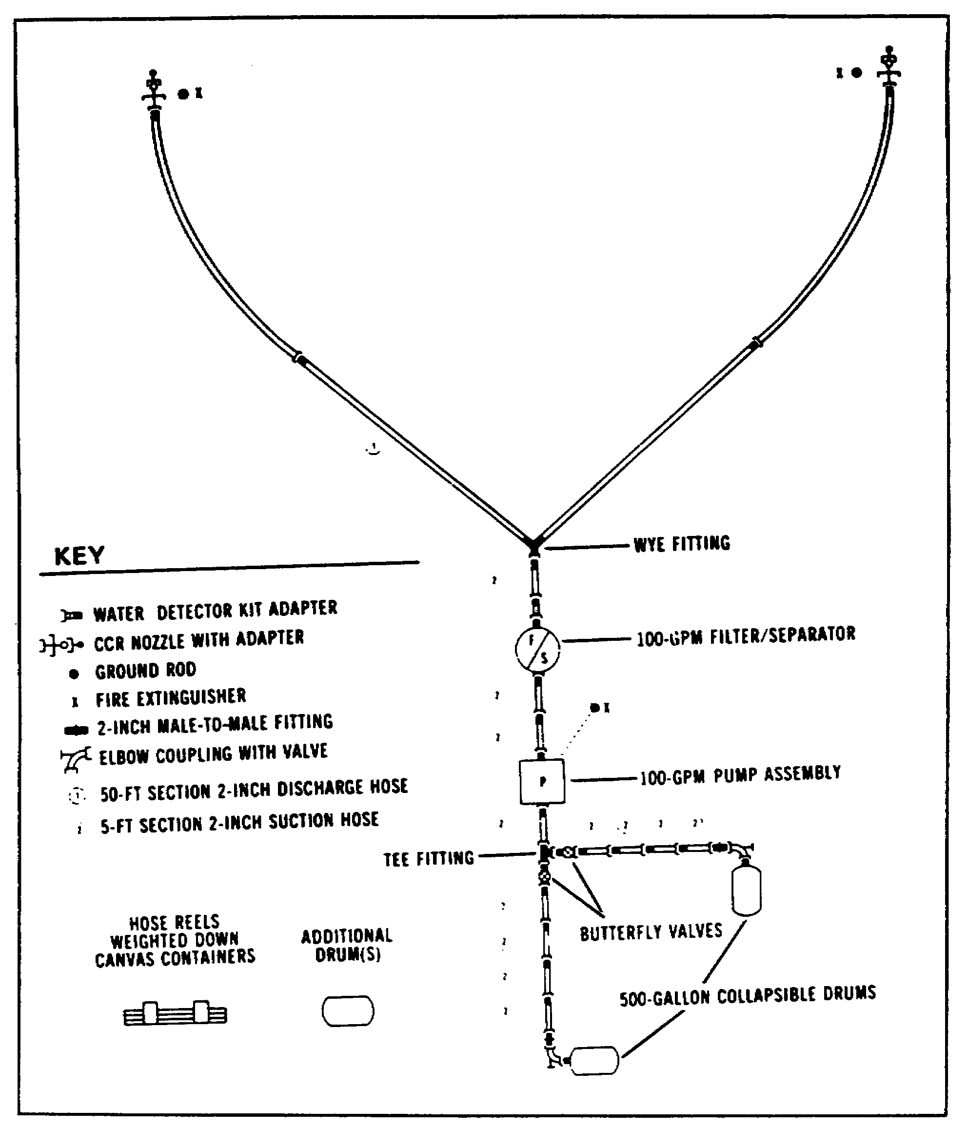

Figure 2-2. Typical Layout of a Two-Point FARE System.

25 AV 0550

b. Typical Layout Site. The spacing between aircraft depends on aircraft type and size--use 100 feet for small aircraft (AH-1, OH-58, or UH-1)(Figure 2-3). Establish a separate refueling point for larger aircraft (CH-47 and CH-54). If both size aircraft must be fueled from the same system, allow 200 feet to the last fueling point to provide a safe margin for rotors and rotor wash (Figure 2-4). Recommended side-by-side, rotor hub-to-rotor hub is 200 feet; minimum spacing is 120 feet. When landing nose-to-tail, the recommended spacing is 160 feet and the minimum is 140 feet. The recommended distance provides adequate spacing no matter what the landing direction. The UH-60 aircraft should be given 125 feet from hub-to-hub with a minimum of 100 feet.

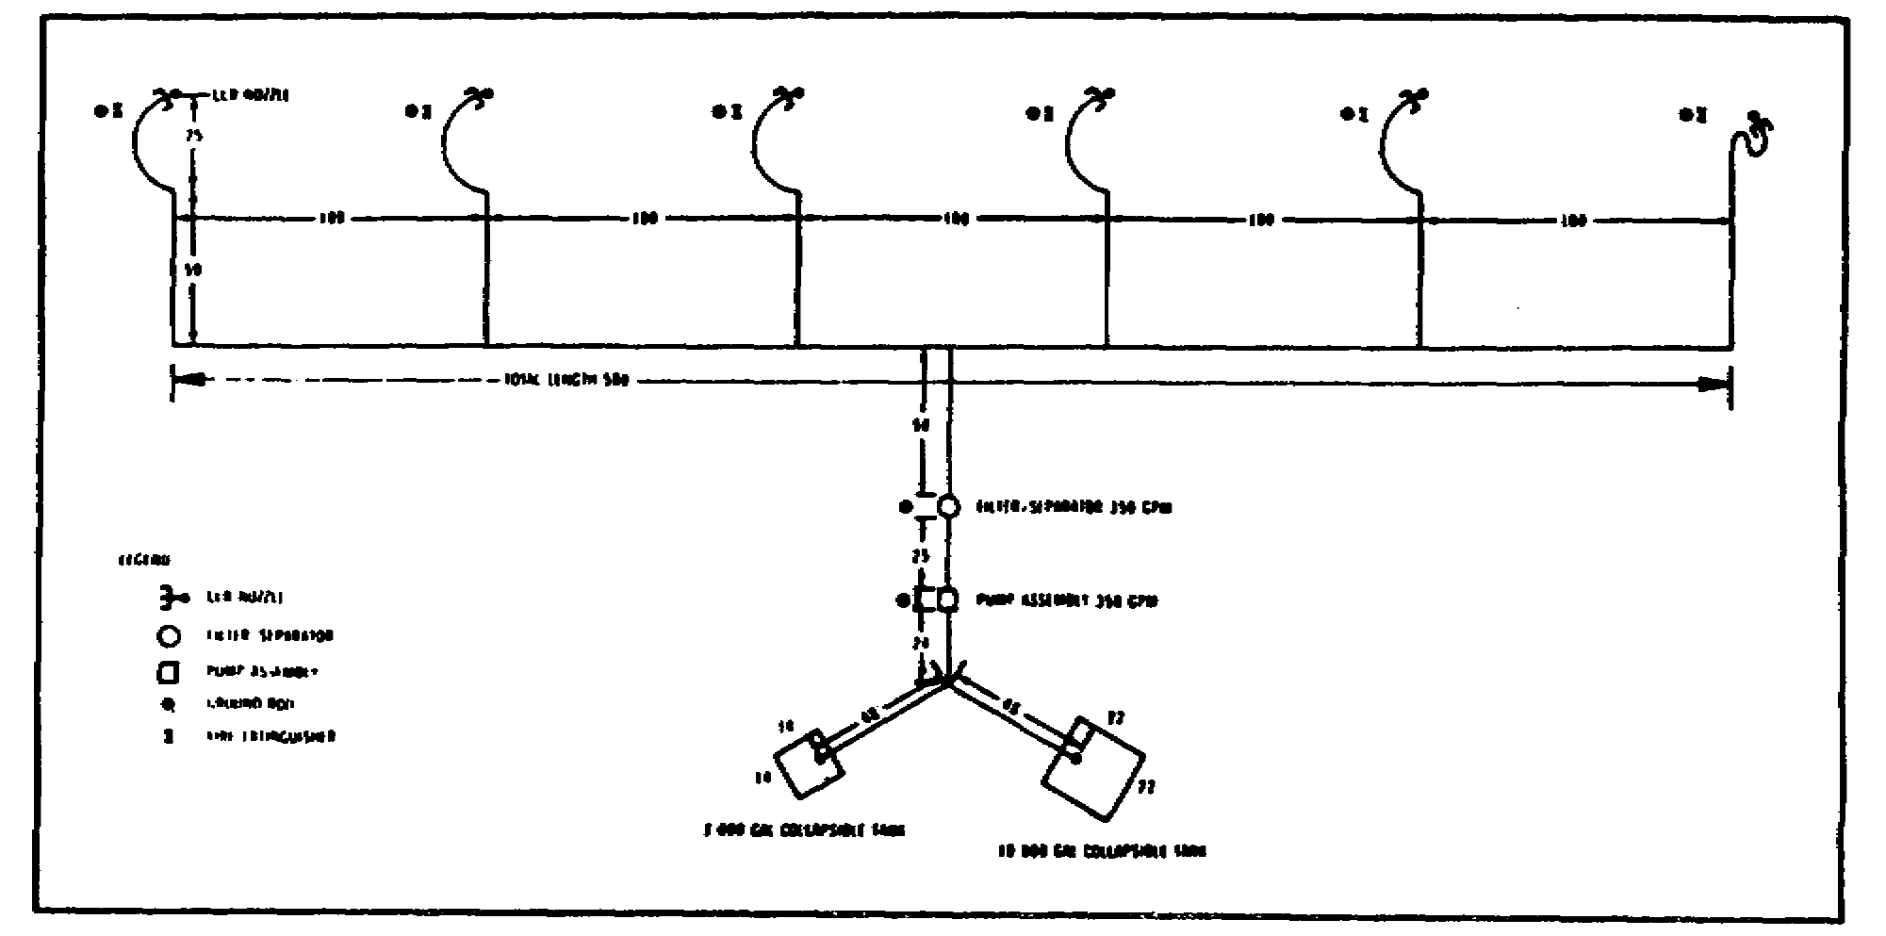

Figure 2-3. Layout of Six-Nozzle Temporary Refueling System
for AH-1, OH-6, OH-58, and UH-1 Helicopters.

5. FUEL TANK VEHICLES

Normally, tank vehicles are used to refuel aircraft on a flight line. They are used when it is more practical to take the fuel to the aircraft than to bring the aircraft to the fuel. All aviation fuel must be filtered before it is loaded into a refueler. Aviation fuel must be filtered again before being pumped into an aircraft. Refuelers that have the letter "C" in their identifier (M49C or M131A5C) are equipped with filter-separators.

26 AV 0550

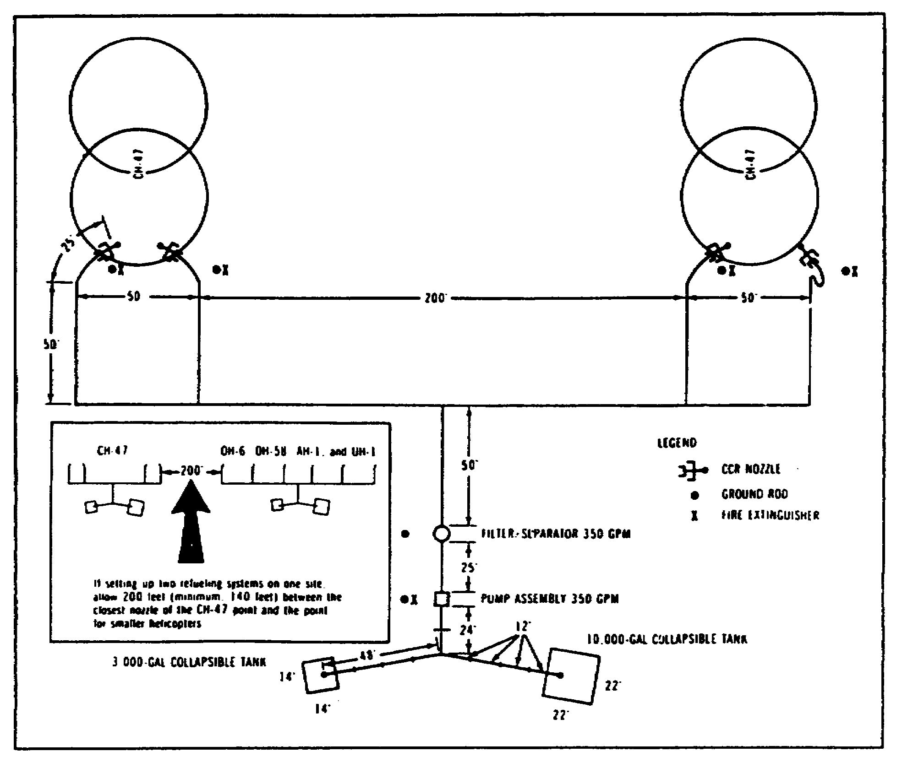

Figure 2-4. Layout of the Temporary Refueling System
for CH-47 Helicopters.

a. M969 Semitrailer. The M969 is used primarily for automotive refueling. It is equipped with a filter-separator and a dual dispensing system. Each system has a meter, hose reel, 50 feet of 1 1/2-inch hose, and a dispensing nozzle. The M969 is used for open-port refueling and cannot be used when the D-1 or CCR nozzle is required. Fuel flow is approximately 60 gpm through one or both nozzles simultaneously.

b. M970 Semitrailer. This is a 1,500 gallon semitrailer designed for underwing or overwing aircraft refueling. The M970 uses the same engine as the M969 but produces a greater flow rate. It also has a filter-separator recirculation system and two refueling systems. The underwing refueling system consists

27 AV 0550

of 50 feet of 2 1/2-inch hose, an electrical rewind reel, a single dispensing nozzle, a breakaway fitting on the hose reel, and a deadman control. The overwing refueling system consists of 50 feet of 1 1/2-inch hose, an overwing dispensing nozzle, an electrical rewind hose, and a CCR dispensing nozzle. The recirculation system provides fuel sampling and complete recirculation of fuel through the filtering and dispensing system to remove condensation and contamination.

c. M131A5C. The M131A5C tank semitrailer is used in open-port refueling of aircraft that have maximum fuel acceptance rates of 225 gpm. The semitrailer may also be used to carry, transfer, or service containers on the ground.

(1) Tank body. The tank is made of stainless steel and has two compartments; each compartment holds 2,500 gallons of fuel. A slip-proof walkway of steel grating runs along the top of the tank body, providing a safe walkway across the top of the tank. Each compartment has a 20-inch manhole cover with a filler cover and lock, an emergency dump valve, and a drainpipe. A load level indicator is welded to the collar of each manhole.

(2) Side cabinets. The M121ASC has an equipment cabinet on each side of the tank body. The roadside cabinet holds a reel of 1 1/2-inch reinforced hose with a standard 1 1/2-inch, automotive type of nozzle equipped with a 100-mesh nozzle screen; a reel of 2 1/2-inch reinforced hose with a 2 1/2-inch, automotive type of nozzle equipped with a 100-mesh screen; the rate-of-flow selector dial; the engine control instruments; and the filter-separator pressure gauges. Manifold valves and dump valve levers are also in this cabinet. The curbside cabinet holds the pump, pump engine, and battery.

d. M131A3C and M131A4C. The uses of the M131A5C and M131A4C are the same as those of the M131A5C. The main difference between these two older models and the newer M131A5C is the tank configuration. These models have four tank compartments; each compartment holds 1,250 gallons of fuel. There are slight differences in the pump, pump engines, hose reels, filter-separators, and other equipment as well as their location. The M131A3C has, in its roadside cabinet, a 50-foot section of suction hose and an automotive type of nozzle that has two adapters with built-in screens. The M131A3C and M131A4C have three 15-foot sections of suction hose stored in hose tubes. The M131A4C has a rear roadside cabinet with a reel of 2 1/2-inch hose and a 2 1/2-inch nozzle. The forward roadside cabinet of the M131A4C has a 1 1/2-inch hose reel with the standard l8-inch automotive type of nozzle.

28 AV 0550

6. TANK TRUCKS

a. M49A2C. The M49A2C is used in open-port aircraft refueling, in transporting fuel, and in servicing fuel containers and ground vehicles. It has a stainless steel 1,200-gallon tank. The tank is evenly divided into two compartments. Power for the pump comes from the truck engine. A speed control linkage controls the speed of the truck engine, its power takeoff, and the fuel-delivery pump. A 35-foot length of 1 1/2-inch reinforced hose with a standard 1 1/2-inch automotive type of nozzle is equipped with a 100-mesh nozzle screen and is mounted on the road side of the tank.

b. M559 Tank Truck Goer. This tank truck is used to refuel aircraft, to transport bulk fuels, and to service combat vehicles. It can move over rough terrain where other vehicles cannot operate. The M559 tank truck has a stainless steel, 2,500-gallon tank. The fuel system of the truck includes a pump, a filter-separator, and fuel handling controls. This system, with the exception of half of the filter-separator, is in an equipment cabinet at the rear of the fuel tank. The 300-gpm pump used to transfer fuel is started by a control lever on the left side of the drivers seat. The GOER has three hose reel assemblies. One hose reel assembly is in the left rear storage cabinet and one is in the right rear storage cabinet. Each hose reel assembly has a 5-gpm capacity with a 25-foot section of 1 1/2-inch discharge hose, a 1 1/2-inch nozzle, a hose reel, and a rewind mechanism. The third hose reel assembly is in the center rear storage cabinet and has a 100-gpm capacity. It also has a 25-foot section of 2-inch discharge hose, a 1 1/2-inch nozzle, a hose reel, and a rewind mechanism.

7. TANK AND PUMP UNIT

This unit is used in open-port refueling and is designed to be mounted on a 2 1/2- or 5-ton cargo truck. It can be used instead of, or to supplement the capacity of, a tank semitrailer or truck.

a. Description of Tank and Pump Unit. The tank and pump unit has two aluminum tanks, each holding 600 gallons of fuel. The tanks are mounted on skids that are tied down to the truck bed. The pump, pump engine, filter-separator, hose reels, and other fittings are mounted on a common base. This type of mounting makes it easy to take the pump off of the truck for maintenance work or to use it as a pump unit for fuels that are stored in ground tanks. The tank and pump unit has two 40-foot sections of 1 1/2-inch reinforced hose, each with a standard 1 1/2-inch automotive type of nozzle equipped with a 100-mesh nozzle screen. Each hose is mounted on a reel that rewinds automatically.

29 AV 0550

b. Fuel Pod. A 600-gallon fuel pod may be mounted on the M105 1 1/2-ton trailer and towed by the tank and pump vehicle. If the trailer-mounted fuel pod is completely filled, the gross weight exceeds the trailer limits and a serious rollover potential exists. Therefore, limit the fuel quantity in a trailer pod to 400 gallons.

8. FUEL VEHICLE MAINTENANCE

The filter elements and go/no-go fuses in the filter-separator must be changed every 24 months or when the pressure differential between the inlet and outlet is more than 20 psi. Replace ONLY the filter elements when the pressure differential between the inlet and the internal pressure is more than 15 psi. Replace ONLY the go/no-go fuses when the pressure differential between the outlet and internal pressure is more than 15 psi. Ensure that a daily log is kept on each tanker. Ensure also that the filter-separator housing is marked with the date the filter elements were first used or last changed. Check fuel nozzles daily for the presence of solid particles.

Part B. POL STORAGE AND HANDLING

9. BULK AND PACKAGED STORAGE

Bulk storage containers hold more than 55 gallons of fuel. Military storage equipment is designed to permit rapid construction of facilities or bulk storage of petroleum products as far forward as tactical situations permit. Pipelines with an integral pump station are used when feasible to transport large quantities of liquid petroleum products over long distances. Storage facilities will vary with the type of operation and the requirements of the using units. Portable storage tanks such as the 600-gallon, skid-mounted tanks and the collapsible, 3,000-, 10,000-, and 50,000-gallon capacity tanks are normally used at temporary fueling installations. Generally, packaged fuels are stored in 5-gallon cans, 55-gallon drums, or 500-gallon collapsible drums.

10. STORAGE AND INSPECTION PROCEDURES FOR STORAGE AREAS AND POL YARDS

All POL products should be maintained in a separate stacking area for each product and type of package being used. Nested stacks of filled 55-gallon drums should be placed on dunnage, and approximately 1 foot of space will be maintained between rows. Cans will be stacked in pyramidal stacks with the bungs and vents at the 3- and 9-o'clock positions to keep seals moist. In addition, supervisors and operating personnel should be aware of the items listed in Figure 2-5.

30 AV 0550

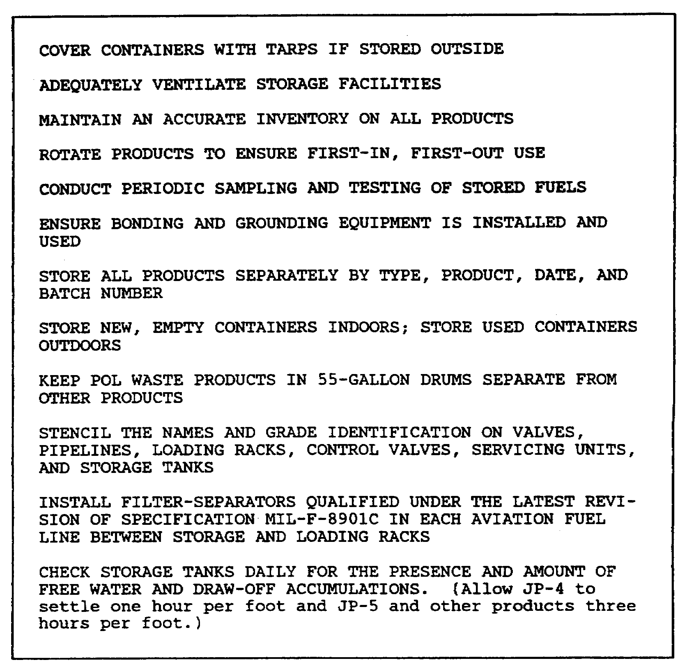

Figure 2-5. Storage and Inspection.

11. SERVICEABILITY CHECKS AND INSPECTIONS

a. POL Yard and Shed. The POL yard must present a neat and clean appearance. The POL shed will be constructed of at least 18 gauge metal. Inside aisles will have a minimum of 36 inches of clearance. Unlike products will be separated. "NO SMOKING" signs will be clearly visible, and fire extinguishers of the appropriate type will be no more than 50 feet away.

31 AV 0550

b. Five-Gallon Can Inspection. Five-gallon cans will be inspected for the condition of painted surfaces and indentions (no more than four dents deeper than 1 1/2 inches or any deeper than 1/2 inch along the edge or rim [chime]). Check for signs of rust or residue inside the can indicating contamination and for holes, rips, or ruptures (except in the handle assembly). Inspect for missing or defective parts (check for missing or defective filler plugs, gaskets, or swivel wire) and for clogged or a damaged parts (clogged vent tubes or a damaged handle assembly).

c. Drum Stacking. Fifty-five-gallon drums will be stacked horizontally with the bungs and vents in the 3- and 9-o'clock positions. They will be inspected twice weekly for leaks, swelling, corrosion, and serviceability. Ensure drums are not badly dented. Check for rust or interior residue and for damage to either flange. Check also for holes, rips, or ruptures.

d. Tanker Separation. Refueling tankers will be separated in the POL yard from other POL products. They will be properly grounded at all times, and preventive maintenance will be performed to reduce fuel hazards caused by faulty maintenance.

Part C. AIRCRAFT REFUELING

12. REFUELING PROCEDURES

Aircraft refueling can be conducted using one of the three basic methods: the FARE system, temporary or semipermanent refueling points, or tank vehicles. Refueling operations common to all three methods are discussed below. When procedures differ from one method to another, they will be highlighted.

a. Hot Refueling From the FARE or Semipermanent System. If you are refueling from the FARE system or semipermanent system, the pump should be started and idling before the first aircraft arrives. The aircrew must ensure that certain procedures are accomplished in the order shown in Figure 2-6.

b. Refueling From 500-Gallon Collapsible Drums. If 500-gallon collapsible drums are used as the fuel source, they will have to be changed frequently. If you use the suction manifold properly, you can keep a continuous fuel flow while you change drums. It is hard even for an experienced person to tell when a 500-gallon collapsible drum is empty because the drum is a closed unvented container. When the drum begins to draw together and has sharp folds, open the elbow valve to the other full container. The pump engine speed will increase and will vibrate when the flow from the first drum gets low. When this occurs, open the butterfly valve to the full drum. When the pump starts to draw fuel from the fresh drum and is pumping at full capacity,

32 AV 0550

the engine speed will return to normal and vibration will stop. Close the elbow valve to the empty drum. If the fuel was not tested before delivery forward, take a sample from each nozzle for inspection. If the fuel passes visual inspection, continue operations; if it fails the visual inspection, radio for instructions. DO NOT USE FUEL THAT HAS NOT PASSED INSPECTION. After doing the visual inspection, unlatch and remove the elbow valve coupler from the empty drum. Get someone to help fold up and move the empty drum and roll a full drum into place. Latch the suction manifold to the fresh drum by coupling the elbow valve coupler to the drum adapter.

13. REFUELING CREW DUTIES

a. Pump Operator. The pump operator watches the refueling operation and operates the pump. The pump is run at full throttle during refueling operations and at idle or at off when waiting for other aircraft.

b. Nozzle Operator During CCR. Insert the nozzle into the receiver (fill port) mounted on the aircraft. If the nozzle and receiver will not mate, look for dirt in the fill port. Wipe out the port with a clean rag, wipe off the nozzle, and lock the parts together. Pull back on the control handle latch and then push the flow control handle up and toward the aircraft into the FLOW position. If the tank is to be filled completely, watch the back of the nozzle; when the flow stops automatically, a red indicator will pop out at the back of the nozzle. If the tank is not to be filled completely, watch for the pilot to signal when to stop the flow. When the signal is received from the pilot or the red indicator pops out, pull the flow control handle back toward the hose into the NO-FLOW position.

c. Nozzle Operator During Open-Port Refueling. Take the dust caps off the front of the nozzle and the back of the open-port nozzle adapter. Lock the adapter into the nozzle before bonding the nozzle to the aircraft and removing the nozzle dust cap and the fill port cap or plug. Open the bypass port and pull back on the control handle latch; then push the flow control handle into the FLOW position. Slowly squeeze the trigger of the open-port nozzle to let the flow start. Watch the pilot for a signal if the tank is not to be filled completely. When the tank gets close to full, let up on the trigger and finish filling slowly. Release the trigger and pull the nozzle flow control handle back to the NO-FLOW position. Drain the remaining fuel out of the nozzle before taking it out of the fill port.

d. Refueling from Tank Trucks. After the aircraft engines are stopped and the rotors have stopped turning, the sequence of refueling can start as follows:

33 AV 0550

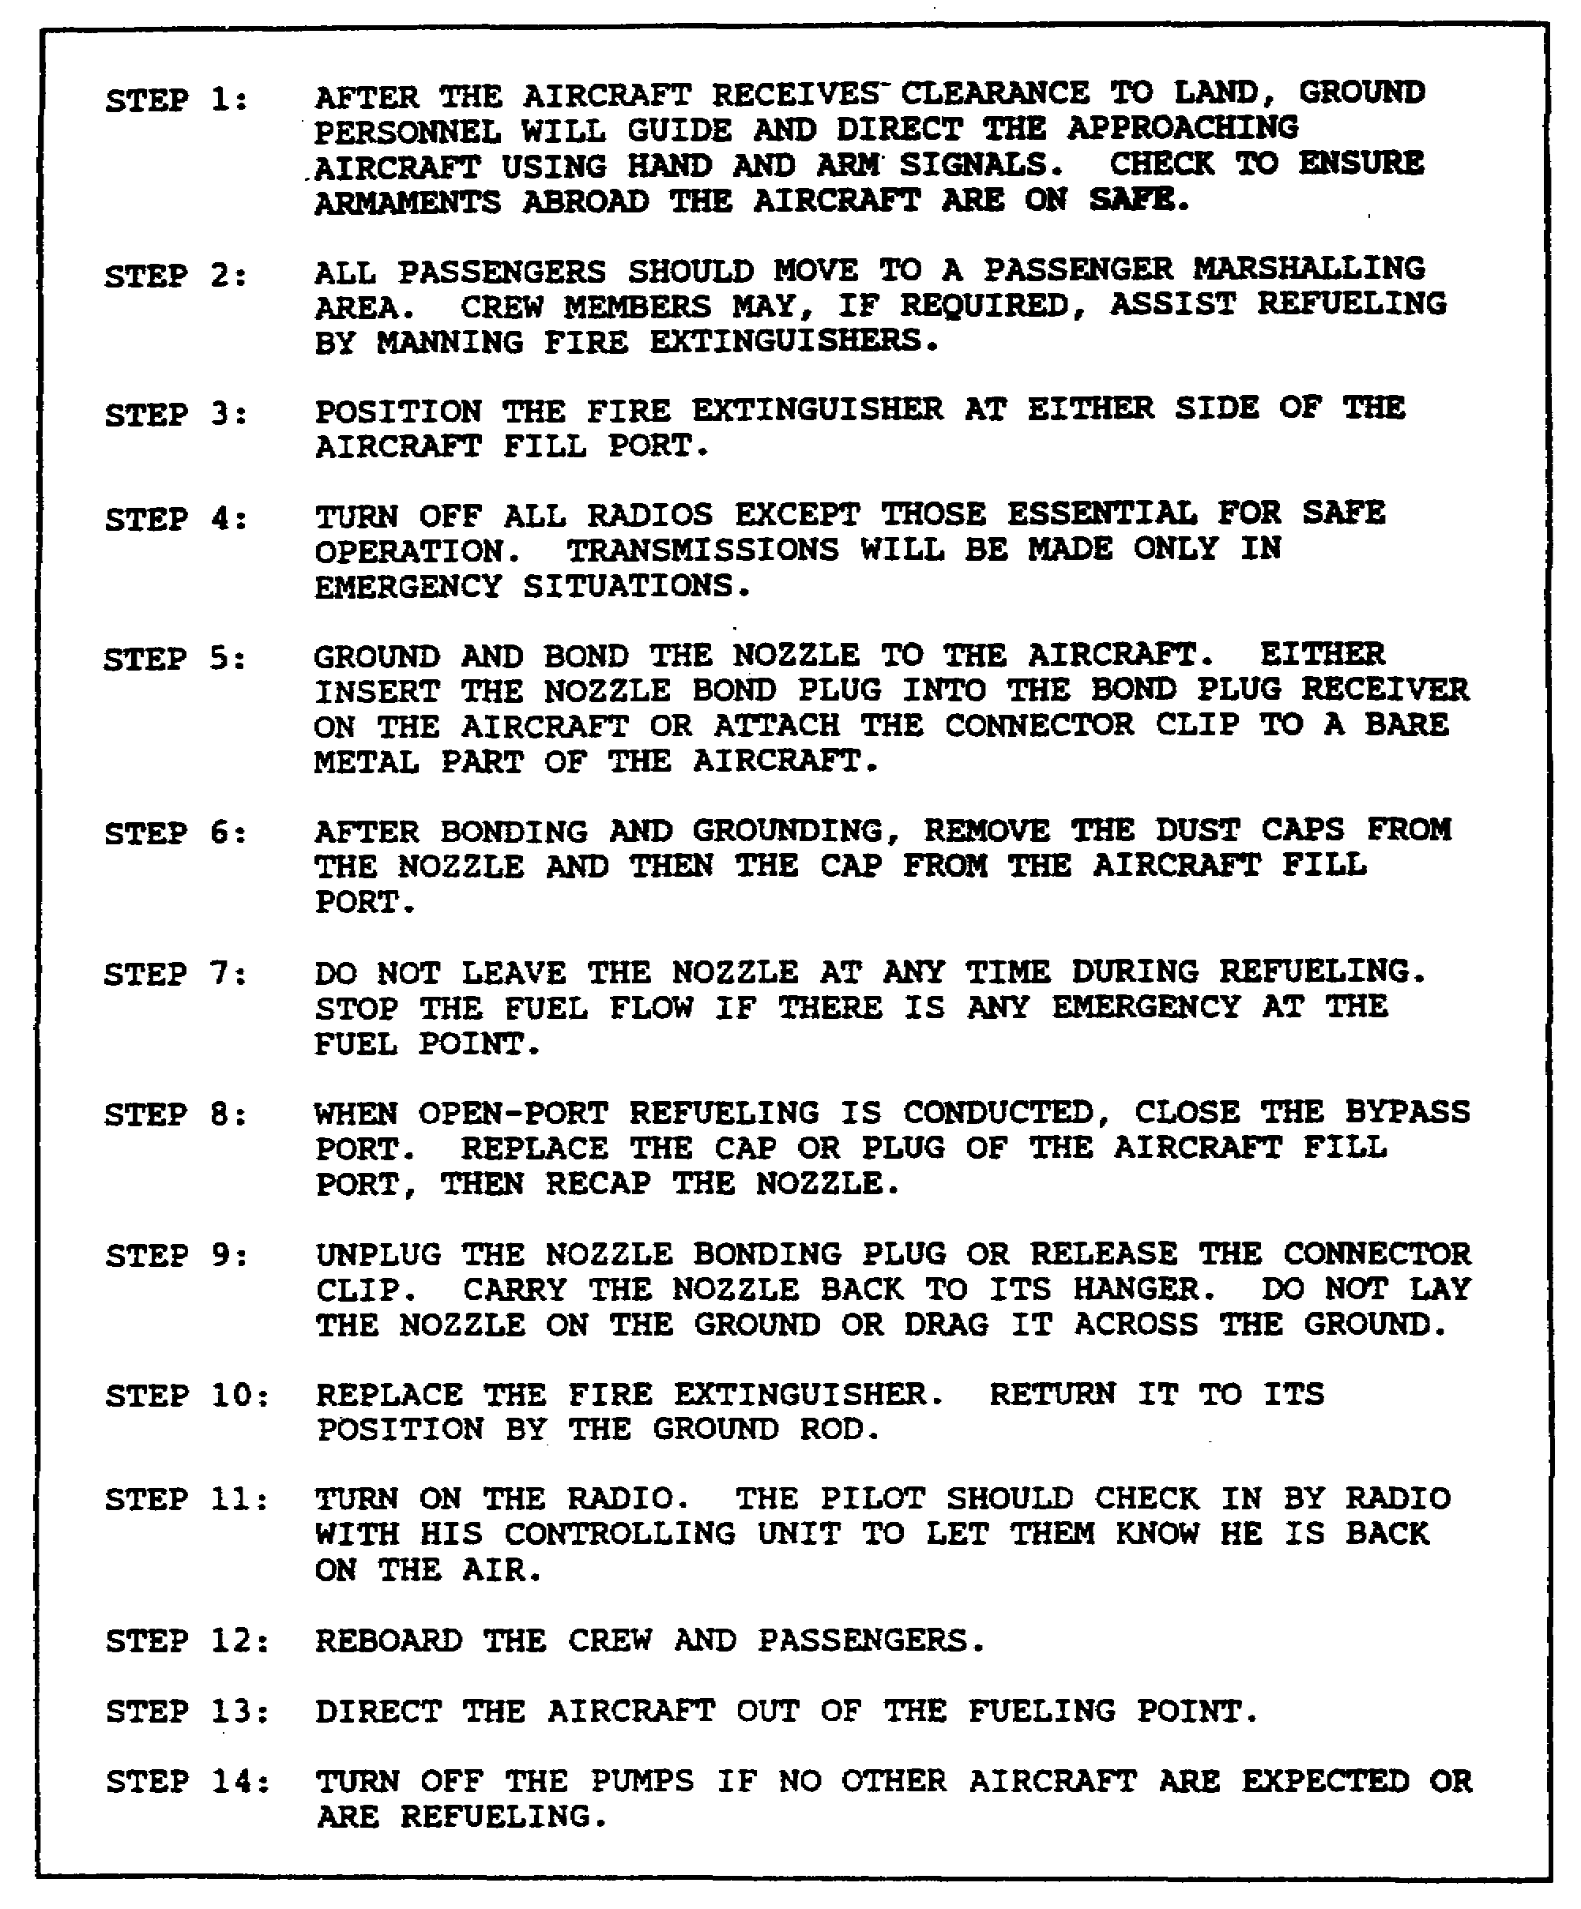

Figure 2-6. Aircraft Refueling Procedures.

34 AV 0550

(1) Check the aircraft. Check the interior of the aircraft. NO ONE SHOULD BE ABOARD DURING REFUELING unless the pilot must monitor the quantity of fuel to be loaded. When the D-1 nozzle is used, the only way of knowing when to stop the flow is for the pilot to watch the fuel gauges. Check with the pilot to confirm that the weapon systems are safe.

(2) Drive the refueler into position. Drive the tank vehicle into position in front of the aircraft. Do not drive the refueler directly toward the aircraft--brake failure could cause a serious accident.

(3) Approach the aircraft. If the refueler can be driven into position without backing, do so. If the refueler must back toward the aircraft, bring the truck to a full stop when 20 to 25 feet away from the aircraft or its rotor blades. Have another person act as a ground guide. Follow his signals to guide the final backing approach until he stops the refueler at the proper distance from the aircraft and its fill port and vent.

(4) Keep a safe distance. Keep a safe distance of at least 10 feet between the refueler and the aircraft. There must be at least 10 feet between the refueler and the rotor blades of a helicopter. Keep a distance of at least 20 feet between the exhaust pipe of the pump engine and the aircraft fill port and tank vent.

(5) Park the refueler. The refueler should have a clear and open path to drive away from the aircraft in an emergency. Do NOT detach a tanker semitrailer from its tractor when refueling an aircraft. The tractor must be ready to pull the trailer away from the aircraft if the need arises.

(6) Stop the refueler engine. Stop the refueler's engine (unless it powers the pump) and set the brake. Chock the tires of the refueler and of the aircraft if appropriate.

(7) Check the fuel. Check the fuel in the tank to make sure it is the right type for the aircraft. Check the sight glass of the filter-separator to make sure all water has been drained.

(8) Position the fire extinguishers. Place the truck fire extinguisher by the pump. Place a fire extinguisher (provided at the refueling point) by the aircraft fuel port. Have members of the ground aircrew man these fire extinguishers. If there is no one available, place the extinguishers near the pump and nozzle operators; position them so that they will not be in the operator's way and where they are not likely to be engulfed if a fire occurs at either the pump or the nozzle.

35 AV 0550

(9) Ground the refueler. Unreel the grounding cable and attach its grounding clip to the nearest grounding rod (Figure 2-7). If you are refueling where no grounding rod is installed drive the refueler's grounding rod into the earth to the required depth and attach the clip to the rod.

(10) Ground the aircraft). After grounding the truck, ground the aircraft (Figure 2-7) by attaching one end of a grounding cable to the grounding rod and the other end to a bare metal part of the aircraft. Use the axle of the landing gear or some other unpainted metal part; do not clip to a propeller or the radio antenna. Attaching this clip grounds the aircraft and bonds the refueler to the aircraft. If the refueler does not have a Y-cable that will ground the refueler and the aircraft to one grounding rod, a separate ground is required to ground the aircraft. A wire, such as building wire (solid copper, type TW, number 14 AWG or larger) or any other solid copper wire (size number 14 or larger) may be used.

(11) Bond the nozzle to the aircraft. Bond the nozzle of the aircraft (Figure 2-7) before you take the dust cap off the nozzle and the cap off the fill port. If the aircraft has a bond plug receiver, use the plug; if not, use the clip-to-bare metal method.

(12) Open the fill port. Open the aircraft fill port and remove the nozzle dust cap. If you are using an open-port nozzle or the CCR nozzle adapter, put the nozzle well down into the port. Do NOT open the nozzle until it is inside the receiver. If the CCR nozzle is being used, mate the nozzle into the receiver. If they will not mate, clean the receiver and nozzle of any dirt.

(13) Refuel.

(a) CCR. Pull back on the control handle latch and then push the flow control handle up toward the aircraft into the FLOW position. If you are to fill the tank completely, watch the back of the nozzle for the red button to pop. If only a partial fill is required, the pilot should indicate when enough fuel has been placed on board. At the completion of filling, pull the flow control handle back toward the hose to move into the NO-FLOW position. Unlatch the nozzle, replace the dust cap, and close the aircraft fuel port.

36 AV 0550

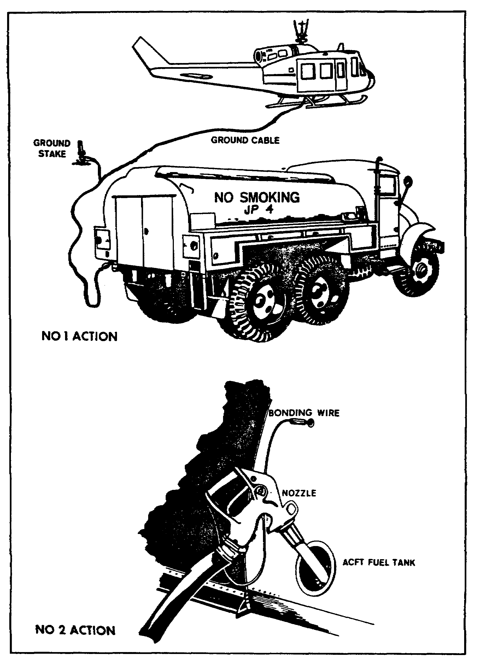

Figure 2-7. Open-Port Grounding and Bonding techniques
of Refueling Operations.

37 AV 0550

(b) Open-port. When conducting open-port refueling, it is most important that the nozzle never be left unattended or wedged in the open position. If any question of safety arises during the fueling operation, the operation should be halted and the system secured until the danger has been corrected or has passed. When filling an aircraft you should slow the flow rate as the fuel approaches the fuel port so as not to cause a spi1.1 or splash on the operator.

(c) D-1. Mate the D-1 nozzle to the receiver mounted on the aircraft by gripping the handgrip handles and turning them clockwise, parallel to the hose line, to allow the fuel to flow. The latch handle will not turn to the OPEN position unless the nozzle is locked to the receiver. If it will not turn, release the nozzle by turning the handgrip counterclockwise and start over, Start the flow by squeezing the deadman control. Stop the flow by releasing the pressure on the deadman control when the pilot signals for the refueling to stop. Turn the latch counterclockwise to release the nozzle from the receiver. The handgrip handles will not turn back to release the nozzle unless the latch handle has been turned back to the NO-FLOW position.

(14) Close the fill port. Replace the cap on the fill port, and replace the nozzle dust cap before you disconnect the nozzle bond.

(15) Disconnect the nozzle bond. Remove the nozzle bond or undo the alligator clip. Reel up the hose and nozzle being careful not to drag the nozzle across the ground.

(16) Disconnect the aircraft ground. Disconnect the clip that grounds the aircraft. Replace the fire extinguisher used at the nozzle.

(17) Disconnect the refueler ground. Release the clip on the grounding rod, and reel up the grounding cable. Do not drag the cable clips. If the refueling operation is over and the refueler's grounding rod was used, pull the rod up and stow it. Replace the fire extinguisher in the refueler.

Part D. DEFUELING OPERATIONS

The fuel must be removed from an aircraft's fuel tank when maintenance work is done on the fuel system, when the fuel level gauges are to be checked or calibrated, when the weight and balance of the aircraft are to be computed, and when work on the aircraft requires the use of electrical equipment of any other equipment the might generate heat or sparks. The tanks must also be defueled if the aircraft is to be shipped or stored. Defueling is more dangerous than fueling even though relatively small

38 AV 0550

amounts of fuel are involved because the procedure is more difficult and drainage provisions are usually inconvenient. All safety precautions must be observed. The general rule of defueling is that it must be done outdoors (except as provided below) without damaging the aircraft or its fuel system, without fuel waste, and without safety violations

14. DEFUELING METHODS

a. Power Defueling. The bulk of the fuel in the aircraft tanks should be removed by suction. A pump or engine assembly or the pump of a refueler provides the power. The aircraft can be defueled either with a defueling tube or by using a piece of suction hose. A defueling tube is fitted onto the suction hose, the tube is inserted into the tank, and most of the fuel is pumped out. The other satisfactory method involves use of a salvaged piece of 1 or 1 1/2-inch suction hose. If a length of 1 or 1 1/2-inch suction hose has been damaged, the coupling at the damaged end may be cut off and the remaining portion used as a defueling tube. The end of the hose should be cut at an angle so the reinforcing wire is cut only once. This cut of the reinforcing wire should be rounded to keep it from damaging the neoprene fuel tank.

b. Gravity Defueling. Gravity defueling is the process of draining the tanks by opening the drain valves or petcocks of the aircraft fuel system. It is also a slow and dangerous process. A suitable container must be placed under the valve to catch the fuel. Except in an emergency, this method should be used only to complete the draining of the aircraft fuel system after the bulk of the fuel has been removed by a pump.

15. DEFUELING PROCEDURES

a. Aircraft defueling must be done outdoors, except as provide below. Aircraft fuel tank openings must be at least 50 feet from any hangar building and must be the proper minimum distance from radar equipment. No aircraft, vehicle, piece of electrical equipment, open flame device, or any other spark generator must be allowed to operate within 50 feet of the aircraft. No smoking is allowed within 50 feet of the aircraft. Aircraft engines and radios must be shut down. All defueling operations must be stopped if there is an electrical storm in the immediate area or if there is a fire, spill, crash, or accident at the refueling point or airfield.

b. Because of the danger, only those personnel actually required to conduct the defueling operation and man the fire equipment must be allowed within 50 feet of the aircraft. Trained fire fighters must stand by with fire extinguishers. A fire truck must stand by with its hose deployed during the entire

39 AV 0550

defueling operation. If no fire truck is available, fire fighters must be notified when and where the defueling will take place and the amount of fuel involved.

16. DEFUELING INTO A TANK VEHICLE

All procedures of open-port fueling apply to defueling--bonding and grounding procedures for defueling are the same for fueling. In defueling, position the tank truck as far from the aircraft as possible, ground the tank vehicle, and bond the defueling tube of the suction hose to the aircraft either with the bonding plug or clip. Insert the suction tube through the aircraft fill port and start pumps. Once the fuel has been pumped out, shut down the pump, remove the hose, and close the tank port of the aircraft. Disconnect and stow the bonding lines, and then disconnect and stow the grounding lines. The defueling truck then may depart to dispose of the fuel.

17. GRAVITY DEFUELING

Gravity draining is a dangerous procedure. The fuel builds considerable static charge as it falls into a container, splashes, and agitates the fuel already in the container. The person who opens the aircraft fuel system drain valves or petcocks is likely to get his arm and sleeve wet with fuel. Fuel-soaked clothing should be removed with care, observing all safety precautions. Fuel should be washed off the skin with soap and water. A fire truck, or personnel with fire extinguishers (if no fire truck is available), must stand by during the entire operation. Proceed as follows:

a. Ground the aircraft to a grounding rod by connecting a cable to an unpainted surface of the aircraft other than the radio antenna or propeller and to a grounding rod driven to the proper depth. Ground the container into which the fuel is to be drained by attaching the alligator clip at one end of the cable to the container and the other end to the grounding rod.

b. Open the valves or petcocks and drain the remaining fuel from the aircraft fuel system. Do not leave draining fuel unattended at any time as spillage may occur if the container overflows.

c. After draining is complete, disconnect the ground to the aircraft and then the ground to the container of fuel. Dispose of the drained fuel as appropriate.

NOTE: Avoid breathing fuel fumes at all times; wear a proper protective breathing mask, gloves, and eye protection.

40 AV 0550

18. DEFUELING INDOORS

When an aircraft is scheduled for maintenance, consider seriously the possibility that the fuel system may have to be drained. Whenever possible, the aircraft should be defueled outdoors before it is moved into a hanger or maintenance tent. During routine maintenance disassembly, unexpected conditions may make indoor defueling necessary. If the aircraft is either in a jig or on jacks when the discovery is made, moving the aircraft outdoors may be impossible. If this is the case and indoor refueling is the only option, proceed as follows:

a. Move all aircraft that can be moved out of the hanger by at least 50 feet. Open the main doors of the hanger, and close any office or shop doors that open into the hanger. Opening the main doors provides maximum ventilation as well as allows the force of an explosion to dissipate.

b. Turn off all engines, electrical equipment, or other possible spark sources within 50 feet. Do not start or continue the operation if there is an electrical storm in the immediate area or if there is a fuel spill, crash, fire, or any other emergency at the airfield.

c. Have a fire truck stand by, if possible, with its hoses deployed. If there is no fire truck, station trained fire fighters nearby with fire extinguishers ready. Clear the area, for at least 50 feet, of personnel and equipment that are not required for defueling.

d. Defuel the aircraft by either of the manners described above. Defueling into a tank vehicle is the safest. Defuel by gravity if the vehicle is not able to approach near enough or if a tank is not available.

19. EMERGENCY AND RESCUE PROCEDURES

There is no hard and fast rule for what you should do in case of fire because too much depends on the specific situation and on where the fire breaks out in the system. The best preparation you can make to properly react to a fire is knowing the dangers, knowing how to use your fire extinguisher, and preparing yourself to make an instant decision and to take instant action. If fire breaks out, plan for and carry out immediately the basic actions described below:

a. Ground Crew. If you are the tank vehicle driver or another member of the ground crew, you should--

(1) Stop the fuel flow by turning off the pump. If the pump has caught fire, use the fire extinguisher instantly.

41 AV 0550

(2) separate the aircraft and the refueling vehicle. The bulk fuel in the truck is the most single dangerous item on the scene.

(3) Give the alarm. Use the existing alarm system to notify fire, rescue, and other personnel of the emergency. You must have a working knowledge of this system before any emergency in order to use it if the need arises.

(4) Attempt to rescue and to contain the fire. If the fire involves the aircraft or crew members, attempt to rescue them or to keep the fire clear until they exit the aircraft and are safe. Aircraft crash rescue charts are available, so study the ones for the aircraft you normally fuel; then, in the event of a fire, you will have a solid background on aircrew rescue hatches and doors.

(5) Extinguish the fire if at all possible, or isolate it until fire fighting crews arrive.

b. Aircrews of Other Aircraft. The ground crew will shut off the fuel flow and disconnect the hose lines and bonding and grounding cables from all other aircraft. The pilot of each aircraft that is not involved in the fire or emergency should bring his engines up to operating revolutions per minute (rpm) as quickly as possible and move away from the danger. Aircrew members should remain on the ground to assist with rescue and fire fighting efforts using equipment available at the site. If the emergency is a crash, other aircraft should prepare to lift off and then follow the instructions of the air traffic controller.

c. Secure the Area. The extent to which the area must be closed depends on the nature and type of fire or accident and the extent of the damage. At a large temporary refueling point in a secure area, it may be possible to close off only the area affected by the fire or accident while continuing operations on other parts of the field. If a fuel spill has occurred, the area must be cordoned off and a fire guard posted until the spill is cleaned and all vapors have dissipated. In the case of a crash in a secure area when the cause of the crash is unknown and particularly when lives are lost, the wreckage must be secured and protected until the investigation group takes charge of the scene. After an aircraft mishap, fuel samples are taken by an accident investigating team appointed by the proper authority. Investigation of Class A through E accidents or incidents is required as part of the aircraft accident protection program. They will then make arrangements for security and assume responsibility for the wreckage.

d. Damage Assessment. After the danger has passed and fires are extinguished, begin a damage assessment at once. Give

42 AV 0550

damage assessments to the commander who can decide the best way of providing substitute support for aircraft.

NOTE: After some fires, fuel can be reprocessed. However, under no circumstance should fuel contaminated by extinguishers be used until tested by a laboratory.

e. Site Clean Up. The POL area should be cleaned up as near as possible to the condition before the fire or accident. Replace fire extinguishers; service equipment; clean and test hoses, drums, and other containers; check for other damage; and clean nozzles.

f. Fire Plan Update. After any fire, crash, accident, or near accident, identify the cause, if possible, and analyze the contributing factors. Review and update the fire plan based on the lessons learned. In addition, use the accident as an example when discussing fire and rescue safety and tactics in the training program.

20. WARNING SIGNS AND VEHICLE MARKINGS

a. Signs.

(1) No smoking. Post NO SMOKING signs 50 feet from the refueling areas or any POL storage facilities. These signs warn personnel not to bring lighted material into the area.

(2) Restricted area. At a semipermanent or temporary refueling point where vehicles, repair tools, or activities could pose a spark danger, post RESTRICTED AREA signs. These signs are to keep unauthorized personnel and vehicles at least 50 feet away from refueling areas.

(3) Emergency shutoff. In any fixed or semipermanent refueling system that provides for emergency shutoff of the fuel system, each cutoff point should be clearly marked EMERGENCY SHUTOFF. The signs should also include instructions so that anyone can shut off the fuel system in an emergency.

(4) Alarm. Points or locations where an alarm may be sounded should be clearly marked ALARM. Instruction should also be provided for its use.

(5) Passenger marshalling area. If there is no terminal, clearly mark an area PASSENGER MARSHALLING AREA. This area will be located at least 50 feet from any refueling operation or POL storage facility.

43 AV 0550

b. Landing Aids.

(1) Lighting. Large semipermanent airfields, heliports, and refueling points must be properly and clearly lighted for night operations. Engineers can provide guidance on the appropriate light and power source used. When temporary lighting is required, the emergency marker light set (LIN L64131, NSN 6230-00-542-6680, light set, marker, emergency: airfield runway) may be used. This set includes 12 bean bag lights in a carrying case and includes extra bulbs, tent stakes, and colored lenses. Obtain batteries (NSN 6135-00-050-3280) separately.

(2) Marking. Mark refueling points and landing pads with reflective tape. Number regular landing pads and letter refueling pads. If the pads are not paved, mark them in a similar manner with reflective paint. Additionally, mark existing aircraft hazards with reflective tape or paint.

c. Vehicle Marking. All fuel tank vehicles will be marked with the appropriate markings shown in Figure 2-8.

21. INSPECTING AND CLEANING FUEL TANKS

a. Inspecting. Before you use a petroleum tank vehicle, inspect the interior of the tank to see if it is fit for service. When you do this, use an explosion-proof extension light, flashlight, or electric lantern.

(1) Interior. Check the interior of all tanks for rust, scale, dirt, foreign objects, and water. If you find any of these items, have the tank cleaned before adding fuel.

(2) Coating. Make sure all tanks made of steel are coated with an approved coating regardless of the condition of the surface or the presence of other noncoating preservatives. Take the vehicle to direct support maintenance for vapor-freeing, cleaning, and recoating.

b. Cleaning. Clean both coated steel and stainless steel tanks as frequently as possible to remove sediment, solid deposits, or foreign matter of any kind. If you postpone cleaning, the operation becomes more difficult and the interior surface, especially in stainless steel tanks, becomes subject to corrosion and pitting. Before you start cleaning operations, equip all personnel with protective equipment such as lifelines, rubber boots, and fresh-air respirators. Clean tank as follows:

(1) If necessary, use a very mild nonabrasive household powder or soap. Use a bristle brush and clean cloths to clean the tank interior. Rinse the tank with clean, hot water; and dry

44 AV 0550

it thoroughly. Do not use metal tools, steel wool, steel brushes, or coarse abrasive cleaning powders.

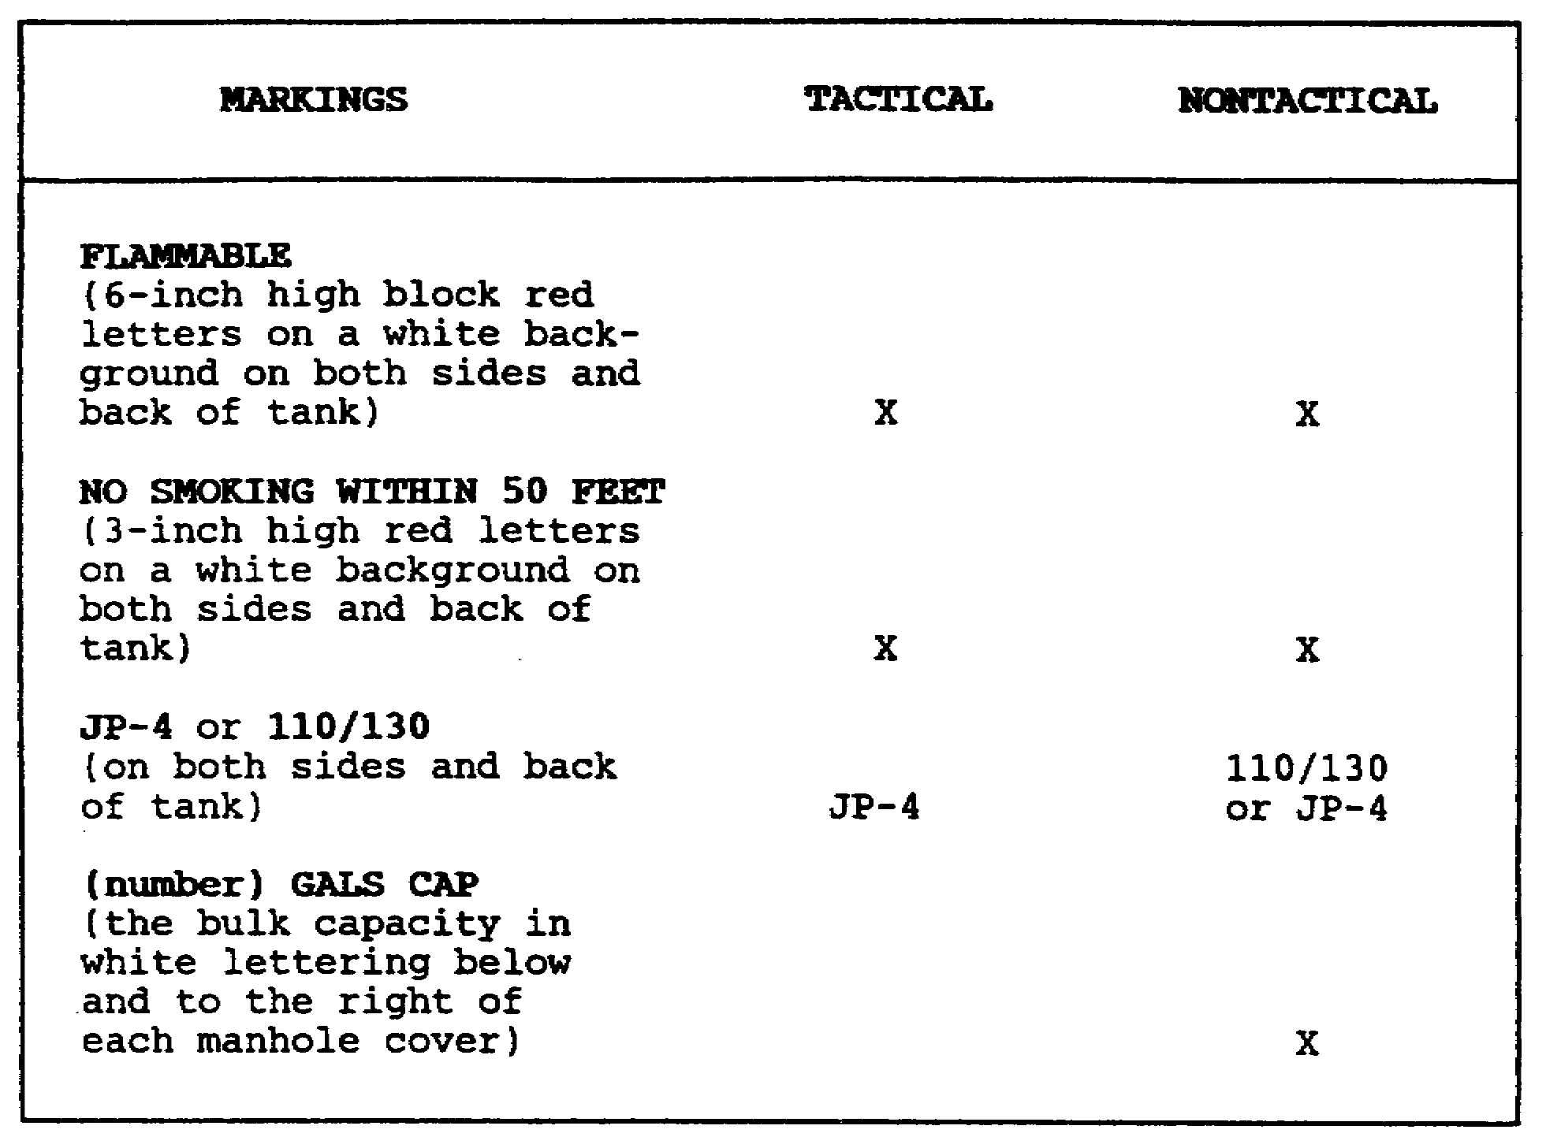

Figure 2-8. Fuel Tank Vehicle Markings.

(2) Put approximately 100 gallons of fuel in the tank and pump it through the vehicle piping system and into each of the other clean compartments. This flushes the tanks and the fuel system of the vehicle. Make suitable arrangements to dispose of the fuel.

45 AV 0550

LESSON TWO

PRACTICE EXERCISE

The following items will test your grasp of the lesson material. Each item has only one correct answer. When you complete the exercise, check your answers with the answer key that follows. If you answer any item incorrectly, restudy that part of the lesson.

1. Utilizing trained personnel, a FARE system can be fully operational within how many minutes of delivery to a site?

A. 15
B. 30
C. 45
D. 60

2. Packaged fuels are NOT generally stored in which of the following quantities?

A. 5 gallons
B. 55 gallons
C. 500 gallons
D. 1,000 gallons

3. In the event of an aircraft mishap, fuel samples should be taken from the aircraft by the

A. unit maintenance officer.
B. accident investigation team.
C. POL officer or NCO in charge.
D. POL laboratory that previously tested the fuel.

4. The M131A5C tank semitrailer can be used to refuel aircraft that have an acceptance rate of up to how many gallons per minute?

A. 200
B. 225
C. 250
D. 275

47 AV 0550

5. Gravity defueling is considered

A. slow and safe.
B. fast and safe.
C. slow and dangerous.
D. fast and dangerous.

6. To operate a closed-circuit refueling system, you must have a CCR nozzle and a

A. flow control valve.
B. latch release lanyard.
C. open-port nozzle adapter.
D. receiver mounted on the aircraft.

7. Tactical fuel vehicles will be marked to indicate no smoking within 50 feet, contents, and

A. capacity.
B. flammability.
C. inflammability.
D. official use only.

8. When refueling from a tank truck, you should

A. bond the nozzle to the tank truck.
B. ground the fuel truck to the aircraft.
C. ground the aircraft to a grounding rod.
D. NOT bond the nozzle to the aircraft before opening the fuel port.

9. Under most circumstances, an aircraft may NOT have to be defueled when

A. the aircraft is taken into a hanger for service.
B. maintenance work is to be done on the fuel system.
C. work on the aircraft requires the use of electrical equipment.
D. the aircraft is to be weighed for weight and balance computations.

10. The M559 tank truck has a capacity of how many gallons?

A. 2,500
B. 3,000
C. 3,500
D. 4,000

48 AV 0550

LESSON TWO

PRACTICE EXERCISE

ANSWER KEY AND FEEDBACK

Item Correct Answer and Feedback

1. A. 15

The FARE system is designed for refueling helicopters in forward areas. It is lightweight and can be flown to the point of use by helicopter. This system is designed to be operational in 15 minutes with skilled personnel. (page 22, para 3a)

2. D. 1,000 gallons

Lubricants, greases, and specialty items are stored, transported, and issued in containers with a capacity of 55 gallons or less, except fuels that are stored in 500-gallon collapsible containers. (page 30, para 9)

3. B. accident investigation team.

Anytime an aircraft mishap occurs, a fuel sample must be obtained, if possible, to determine if fuel contamination contributed to the mishap. (page 42, para 19c)

4. B. 225

The M131A5C tank semitrailer can refuel aircraft with an acceptance rate of 225 using the open-port refueling method. (page 28, para 5c)

5. C. slow and dangerous.

Aircraft defueling must be done outdoors using the drain valves and petcocks of the aircraft. Because of the danger, only those personnel actually required to conduct the defueling operation and man the fire equipment are allowed within 50 feet of the aircraft. (page 39, para 14b)

6. D. receiver mounted on the aircraft.

Closed-circuit refueling is refueling with a system of equipment in which the special aircraft fill port (receiver) and special nozzle mate to form a vaporproof seal. (page 21, para la)

50 AV 0550

7. B. flammability.

Vehicles that carry bulk fuels must be marked on both sides and on the back of the tank body with the words "FLAMMABLE" and NO SMOKING WITHIN 50 FEET." (page 45, Figure 2-8)

8. C. ground the aircraft to a grounding rod.

The grounding rod provides a conductive path into the ground so that a static charge will not be trapped on the surface of the equipment where it could discharge a spark. [page 35, para 13d(1) ]

9. A. the aircraft is taken into a hangar for service.

Recommended defueling operations should be completed outdoors; sometimes it may be necessary to defuel indoors if the aircraft is on jack stands. (page 41, para 18)

10. A. 2,500

The M559 tank truck, also called the Goer, is used to support combat vehicles, aircraft refueling, and bulk fuel transport with a payload of 2,500 gallons. (page 29, para 6b)

51 AV 0550

